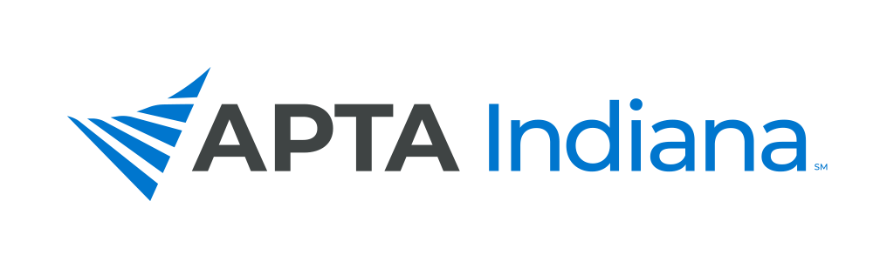
A CALL FOR POSTER PRESENTATIONS

Have you submitted an abstract for CSM? Are you interested in sharing your research with your colleagues? This is an excellent opportunity to share the findings of your studies with others and gain practice presenting a poster or performing a platform presentation.

At the 2025 APTA Indiana Fall Conference, we will have poster presentations from therapists and students in research, special interest, case study, or theory reports. This opportunity is open to all PTs and PTAs with eligible presentations.

We will not be accepting platform presentations this year.

SCHEDULE FOR SATURDAY, NOVEMBER 16

Poster Presentations – 1:00 – 2:00 pm

This is an open time for those in attendance to view the posters, meet the authors, and ask questions. The posters will be assembled the morning and should be up by 12:30 pm. The poster session will end at 1:10 pm. Final details will be provided to those accepted, prior to the Fall Conference.

The APTA Indiana Fall Conference will be held at Indiana State University, College of Health and Human Services in Terre Haute, IN. APTA Indiana Members who are registered for the Fall Conference will have no additional cost to display their poster presentation. For non-members, or members not registered for the Fall Conference, there will be a $25 charge for admittance into the Exhibit Hall and will also include lunch.

An abstract of your poster is required by September 1, 2025, before 11:59 pm ET and should be sent to info@inapta.org.

A panel will review your abstract and notification of acceptance will be given by October 1, 2025. Abstracts will be reviewed in the order that they are received.

There is a 3,125-character limit for the text of your abstract submission which includes spaces, but not authors or institutions. The abstract should use between size 10-12 font with double spacing, and contain the following, based on type of project:
Research Study | Special Interest Report | Case Study | Theory Report
Title | Title | Title | Title
Purpose/hypothesis | Purpose | Background/purpose | Theory/body
Number of subjects | Description | Case Description | Keywords
Materials/Methods | Summary of Use | Outcomes
Results | Importance to members | Discussion
Conclusions | Keywords | Keywords
Clinical Relevance
Keywords

- Keywords: Up to 3
- Abstracts also require presenter/author information including credentials, city, and state.

Any questions or concerns regarding your submission should be directed to info@inapta.org.

