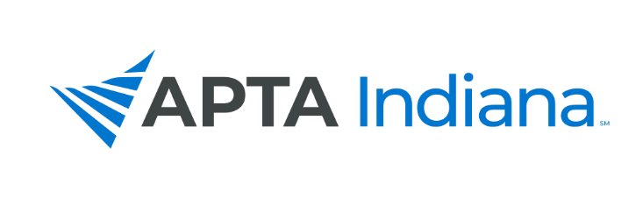
2022 ANNUAL REPORT

Board/Committee/SIG Position: State Legislative Committee (SLC)

Name: Valerie Strunk, SLC Chair

APTA INDIANA STRATEGIC PLAN UPDATE FOR TRACKING SHEET
GOAL & STRATEGY # | UPDATE
Goal 2, Objective #1, Strategies #1 and #2. | PT and PTA telehealth services were successfully added to legislation that was passed in 2022.
Goal 2, Objective #2, Strategies #1 and #2 | Indiana Membership in the PT Compact was successfully passed during the 2021 legislative session. In 2022, the PLA has been working with the PT Compact Administrators to commence use of the PT Compact in Indiana. A date for that is still pending action by the PLA/Board.
Goal 2, Objective #3, Strategy #1 | Practice and Payment have kept the SLC up to date on data and its analysis of payment practices related to telehealth. This is ongoing work that continues.
Goal 2, Objective #4, Strategies #1, #3 | The SLC Committee has realized that work done by the State Legislative and Practice and Payment Committees to forge relationships and coalitions with respect to payment barriers (which is a higher priority to our membership than is unrestricted direct access) should be prioritized, and that this work in building relationships will be beneficial to future work on unrestricted direct access. We plan to spend 2022-2023 working legislatively to impact payment issues, and then use that work to more efficiently work towards direct access legislation in the coming years by leveraging relationships built while working on payment issues. The relationships/stakeholder identification referenced in strategy #3 is work that is being done now.

INCLUDE ADDITIONAL INFORMATION NOT RELATED TO THE STRATEGIC PLAN HERE

This year, the SLC was successful in the 2022 Legislative Session in adding PTAs as a permissible group to provide Telehealth Services with the passage of SB 284.

Through the Summer and into the Fall, the SLC has changed leadership with Valerie Strunk stepping into the Chair position, and Emily Slaven staying on as a member of the Committee. The Committee has been working closely with the Practice and Payment Committee Chair, Andrea Lausch, to understand the parameters of payment barriers in the state of Indiana through her data gathering and analysis to help define the issues more clearly. SLC leadership attended the first annual Healthcare Workforce Summit in August, 2022, with the goal of making connections with other professional stakeholders to find consensus on workforce issues, including practice and payment, which will contribute to legislative advocacy success in the coming months and years.

This summer and fall, the SLC also continues to guide and support several members’ efforts to ask the PLA to weigh in on a PT Scope of Practice Question which would allow for PTs to sit for a Certified Medical Examiners Course and Certification to become approved DOT assessment providers. Currently, the PLA has a policy of not weighing in on scope of practice questions, and the committee has been assisting the members in reaching out to their legislators to clarify this PLA practice and the barriers created by this PLA policy. This effort is ongoing.

