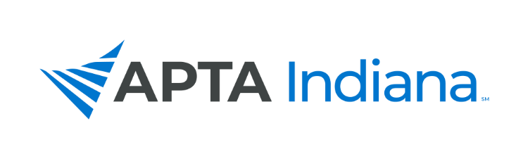
BOARD REPORT

When due: Prior to each Chapter Board Meeting.

Who should complete: Board Members should complete the report after consulting with their liaison committees and send to info@inapta.org.

Board Member’s Name: Andrea Lausch, Practice & Payment Specialist

APTA INDIANA STRATEGIC PLAN UPDATE FOR TRACKING SHEET
GOAL & STRATEGY # | UPDATE
Track Payment Practices from the Use of Telehealth in 2020 and 2021 | Progress: To date, these insurers provide coverage: Medicaid, UHC if filed on 1500 form, Aetna, Cigna if filed on 1500 form. Currently each honors parity of pay. Anthem provides coverage but does not honor parity of pay.
Generate Language for Legislation That Will Promote Parity of Pay | Not Met: 38% of member on a recent membership survey indicated payment for telehealth is equal to in person care, 12% where said it was not the same and 50% were unsure. The payer reported that did not reimburse the same was Anthem. At this time legislation is not planning to be pursued.
Advocate for Payer Policies That Increase Direct Access to Physical Therapy Services | Per a recent payment survey, local state payers that do not permit direct access includes Signature Care, Midwest Operating Engineers, and Auxiant. National payers identified were communicated with APTA and the remaining payers on the survey are regulated by state or federal law.
Provide Member Resources to Facilitate the Use of Direct Access via a “Direct Access Toolkit” | Met: Provided PR committee payer information and research regarding direct access.
Payment Webinars to Update Members on Hot Topics | Met: Provided NW district education on Defensive Documentation to reduce Audits and Denials in May 2022 and planning to offer this webinar to the general membership. Will present with North Central and SW District PA Advocacy Efforts in Oct/Nov.

INCLUDE ADDITIONAL INFORMATION NOT RELATED TO THE STRATEGIC PLAN HERE

INSERT COMMITTEE UPDATES HERE

January 2022 APTA IN BOD Report: Practice and Payment Specialist
Serve as a resource to the APTA Indiana membership on practice and payment issues | - Consulted and/or addressed 30 member inquiries and/or practice/payer issues since last board report. Year to date addressed 99.  - Updated Practice and Payment Webpage  - Completed APTA IN Payment Survey for 2022, Direct to Employer survey, and Indiana Patient Compensation Fund Survey to private practice owners to gain information on payment and practice issues.  - Presented a webinar to the NW district on Defensive Documentation to reduce Audits and Denials.  - Maintaining list of queries.  - Wrote monthly to bimonthly Practice and Payment newsletter  - Served as a resource to the legislative committee.  - Attended Legislative Committee meetings YTD  - Assisted APTA IN Conference Committee with recommendations of a couple of keynote speakers for Fall APTA IN conference.
Establishes working relationships with payer contacts | - Continuing to build relationships with payers.  - Communicated or met with WPS, UHC, NIA/Magellan, Anthem Medicaid, and IN Medicaid YTD  - Attended National Hospital Transparency Conference/Employer Forum of IN meeting in May.  - Attended the Employer Forum of Indiana All Stakeholder meeting in Sept.  - APTA was asked to present at an All Stakeholder meeting on the value of physical therapy. Scheduled for April 2023.  - Medicaid request to add 95992 as a covered code: approved and added to fee schedule.  - Ongoing review of new 2022 payer policies and CMS proposed/finalized policies impacting therapy services across the field.  - Submitted a blog and a white paper to the Employer Forum of IN and Wellness Council of IN on the value of PT to share with their employers.
Communicates with APTA Indiana Board of Directors | - Attended all APTA IN board meetings YTD  - Provided written reports before meetings including updates on work toward the APTA IN Strategic Plan.
Maintains a physical therapy payment database | - List to date includes contacts for: Medicaid and Medicaid MCEs, Anthem commercial, AIM contacts, WPS, UHC, NIA/Magellan, and Cohere  - Maintaining database of ‘Problem Payer” issues, and ‘Practice issues’ members report;
Communicates and collaborates with the APTA Indiana Practice and Payment Committee and APTA | - Provided input to APTA regarding payment issues in state.  - Attended APTA employer/Value Based workgroup and PPS employer Task Force meeting, APTA pay chair and APTA UM meeting YTD. Participated in monthly meetings.  - Attended APTA State Payment Forum in DC in August 2022.  - Met with Practice and Payment Committee quarterly in 2022; updated committee via email on payment related issues.  - Developed Payer Reporting Portal with Practice and Payment Committee
Represents APTA Indiana in advocacy efforts directed at Third Party payers. | - Shared Payment 2022 survey results with PP committee and members of the Legislative Committee, IHA, IOTA, and ISHA.  - In efforts with the Legislative Committee, supported APTA IN joining a coalition to support PA reform.  - Beginning efforts with IOTA and ISHA to request streamlining PA process with Indiana Medicaid.  - Met with Hathaway Strategy regarding advocacy toward Employer-Provided Coverage.  - Attended PT Day at the Statehouse

