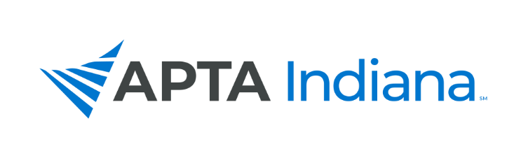

BOARD REPORT

Board Member’s Name: Mackenzie Wilson

Date: 10/9/2022

APTA INDIANA STRATEGIC PLAN UPDATE FOR TRACKING SHEET
GOAL & STRATEGY # | UPDATE
Objective 2, Strategy 3 | Assisted in conversations/meeting surrounding district membership and strategies to recruit leadership
Objective 4, Strategy 4 | Worked closely with Student SIG in development of Student Track of Fall Conference; assisted with recruitment of speakers as well as proofreading presentation Student SIG put together
Objective 4, Strategy 4 | Plan to work with Angie on the transition to a new Core Ambassador, awaiting confirmation of acceptance of the new CA
Objective 1, all strategies encompassed | Worked on reinstituting the New Professional SIG; meetings with Emily and Suzie as well as former member of the NP SIG. Worked with Suzie on creating slate for NP SIG leadership.

INCLUDE ADDITIONAL INFORMATION NOT RELATED TO THE STRATEGIC PLAN HERE

- Continued communication with Student SIG Chair (Tamya) regarding progress with student track for fall conference. Able to meet in person with Tamya and Allie in DC at the Leadership Conference.
- Phone meeting with Angie regarding CA activities and onboarding process with new CA.

INSERT COMMITTEE UPDATES HERE

The Student SIG had all courses approved for the Fall Conference. They are working hard on finishing details for the Fall Conference student track presentations.

The New Professional SIG posted slate of candidates to work on restarting this SIG (yay!).

