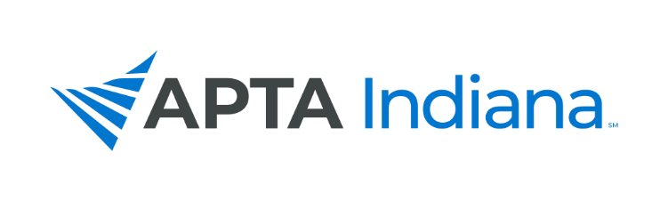
2021 ANNUAL REPORT

Board Member’s Name: Kelly Clark, Southern Region Director at Large

APTA INDIANA STRATEGIC PLAN UPDATE FOR TRACKING SHEET
GOAL & STRATEGY # | UPDATE
Goal 3, Strategy 1, Objective 4 | Attended Centennial Scholars meeting in Washington DC 9/10-9/12 and continued collecting responses to DEI & Engagement-focused survey directed at students & new professionals (open through 11/15/2021, 100+ responses to date): Assessing Barriers to Physical Therapy as a Choice of Profession  Met with Indiana University Bloomington Pre-PT Club to promote above-referenced survey and the work of APTA Indiana BOD & answered questions from 35+ members present on topics ranging from application process to private practice ownership  Began to review and compile survey results in preparation for provision of an executive summary and detailed list of suggestions for improving student / new professional experience entering PT profession, to be provided directly to BOD for review by year end.
Goal 1, Strategy 1, Objective 3 | Communicated with SE & SW District leadership to schedule face-to-face district & state leadership dinner meeting to reconnect, SW district meeting to take place 11/10/2021
Goal 3, Objective 1 | Scheduled to serve as a panelist promoting the use of direct access during fall conference 11/6/2021  Lectured at Indiana University DPT on the topic of direct access & direct-pay based practice 9/14/2021

INCLUDE ADDITIONAL INFORMATION NOT RELATED TO THE STRATEGIC PLAN HERE

The SE District has struggled to engage with district leadership and to locate a full slate of candidates for open district leadership positions, and as a result, did not hold elections in the spring. This has made it difficult to schedule a district leadership meeting.

