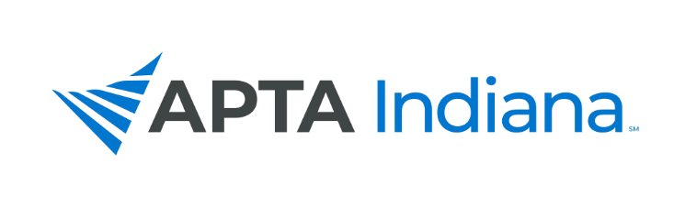

2021 ANNUAL REPORT

Board/Committee/SIG Position: PTA Caucus Representative

Name: Rochelle Hawkins, PTA

APTA INDIANA STRATEGIC PLAN UPDATE FOR TRACKING SHEET
GOAL & STRATEGY # | UPDATE

INCLUDE ADDITIONAL INFORMATION NOT RELATED TO THE STRATEGIC PLAN HERE

- Virtually attended the PTA Caucus Annual Meeting and APTA House of Delegates.
- The PTA Caucus is closely watching the 15% cut that is set to start in 2022, there is legislation out there to move it to 2023. Here is the latest update:
- Beginning in January 2022, payment for services under Medicare Part B provided by physical therapist assistants (as well as an occupational therapy assistant), will be reduced by 15%. These cuts are a threat to physical therapist assistants and may leave many older adults —especially those in underserved and rural areas — with less access to care. Now is not the time to cut therapy services provided by a PTA, given the other multiple cuts under Medicare and the current public health emergency.
- On Oct. 8, U.S. Rep. Bobby Rush, D-Ill., and Rep. Jason Smith, R-Mo., introduced H.R. 5536, the Stabilizing Medicare Access to Rehabilitation and Therapy Act, or SMART Act, in the House of Representatives. This APTA-supported bipartisan legislation is aimed at protecting beneficiary access to therapy services by mitigating the impact of the impending 15% payment differential for services furnished by a PTA under Medicare Part B.
- The legislation would delay implementation of the payment differential until Jan. 1, 2023, and exempt rural and underserved areas from the differential. The proposed legislation would also institute a change long-advocated by APTA: allowing for general supervision of PTAs by physical therapists in outpatient settings (where allowed by state law) under Medicare Part B. Medicare currently allows for general supervision of PTA in all other settings; outpatient practice under Part B requires direct supervision.
- Along with APTA, the legislation has been endorsed by 17 provider and patient groups who expressed their support in a sign-on letter.
- I participated on a PTA Panel for UIndy on 10/21.

