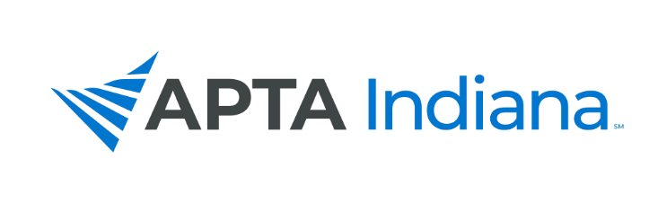
2021 ANNUAL REPORT

Board/Committee/SIG Position: Membership Director

Name: Chris Gales, PT, DPT, MS (Bloomington)

APTA INDIANA STRATEGIC PLAN UPDATE FOR TRACKING SHEET
GOAL & STRATEGY # | UPDATE
Engagement, Objective #1: Targeted Membership Recruitment – New Professionals (PTs/PTAs) | - Chris participated on a Zoom meeting with Kate Zenker’s Early Professionals Task Force to discuss ideas pertaining to a potential Early Professional SIG. Work ongoing with leadership transition.
Engagement, Objective #2: Targeted Membership Recruitment – Students (PTs/PTAs) | - APTA Membership presentation given to PTA Students at Vincennes University, PT Students at Indiana State University, and will be given to UIndy PT Students on Nov 10
Engagement, Objective #3: Targeted Membership Recruitment – Potential (New) Members (PTs & PTAs)  Membership Value “Packet” | - Membership Value Toolkit work by Membership Committee this year. Will be completed and available to be used ‘as a whole’ or sub-sections used to highlight areas of Value in various Newsletters in 2022

INCLUDE ADDITIONAL INFORMATION NOT RELATED TO THE STRATEGIC PLAN HERE

- Added SIX new participants over course of the year! New members included Mike Topor, Brandon Applegate, Sean Collins, Mackenzie Wilson, Cameron Buzzard, and Kate Lindemann to our ‘Legacy’ members of myself, Gail Altekruse and Stacey Rapp.
- Special thanks to Emily for connecting them with us- their new energy and ideas have really helped to shape the upcoming Tool Kit.
- As a few of them are connected to the work of APTA Indiana in other capacities, I anticipate our Committee will change a bit again in 2022.
- I plan to guide the work of the Membership Committee each month to really hone in on the Tasks listed on the Strategic Plan that we did not begin to address in 2021 as my leadership should have facilitated better.

Nominating Committee

- Final Slate of Candidates

Chris Gales | Membership Director
Chelsea Savage | Membership Director
Matt Zaudtke | Treasurer
Frank Bates | Treasurer
Blair Frye | Chief Delegate
Sean Collins | Director at Large-North
Dimple Singh | Director at Large-North
Jessica Baker | Director at Large- South
Rick Reuss | Delegate
Bill Staples | Delegate
Alicia Taylor | Delegate
Elizabeth Coons | PTA Caucus Representative
Barb Settles- Huge | Nominating Committee

- David Jackson resigned from the Nominating Committee and Kate Lindemann was appointed in his place.

Board/Committee/SIG Position: PR Committee Chair

Name: John Kiesel

APTA INDIANA STRATEGIC PLAN UPDATE FOR TRACKING SHEET
GOAL & STRATEGY # | UPDATE
Goal 3 Obj 1 - Provide Member Resources to Facilitate the Use of Direct Access via a “Direct Access Toolkit” | A ‘pilot’ of this website has been sent to the webmaster for loading onto the webpage. I would like to roll it out at the fall conference. Committee will meet quarterly for updates to this.
Goal 3 Obj 1 - Provide Examples of PTs Making the Most of Direct Access in Their Practice via Webinars | A roundtable will take place at the fall conference to share best practices with four clinicians from different settings.
Goal 3 Obj 1 - Direct Access Track at the Fall Conference | CEU’s will be available for the fall conference session. This is focused on marketing, overcoming barriers within the healthcare system, and understanding payment related to DA.
Goal 3 Obj 4 - Engage With Students through the Core Ambassador, Student SIG and PR Committee re: Chapter-Wide Initiatives | PR has been in communication with student SIG to promote activities on Social Media & to PT/PTA programs within the state.

INCLUDE ADDITIONAL INFORMATION NOT RELATED TO THE STRATEGIC PLAN HERE

- We continue to work closely with the Pain SIG on some community outreach initiatives. The plan is to develop a ‘stock’ community outreach presentation that can be shared with members, so that they can present in their local community regarding the role of PT in pain relief.
- We’ve developed a ‘Social Media Calendar’ with monthly themes.

Service Committee

INCLUDE ADDITIONAL INFORMATION NOT RELATED TO THE STRATEGIC PLAN HERE

- The goal for this year was to foster a combination of local district projects and statewide efforts that can connect us as a state chapter. Offerings were available had some reach, but participation was limited outside of central district. Next year we will work on outreach techniques to get all districts more involved as able.
- Projects this year included an annual clean up at IU Student Outreach Clinic (IUSOC), letters against isolation letter campaign, and a central district meeting that packed hygiene bags for IUSOC and wrote letters the letters against isolation program.
- Kevin Herald has agreed to join Hannah Enochs as Co-Chair of the Service Committee! He has helped by leading the clean-up at IUSOC the past two years and will be a great asset to the committee.
- The committee donated $500 to the national PT Day of Service organization this year.

