

**2021 FALL CONFERENCE**

**NOVEMBER 5-6, 2021**

**FRIDAY, NOVEMBER 5, 2021**

**THE RATHSKELLER RESTAURANT**

**401 E. Michigan Street**

**Indianapolis, IN 46204**

**MEET THE CANDIDATE’S RECEPTION** (5:00 - 5:30 pm)

**BUSINESS MEETING** (5:30 - 7:00 pm)

**DINNER AND AWARDS CEREMONY** (7:00 – 9:00 pm)

**SATURDAY, NOVEMBER 6, 2021**

**UNIVERSITY OF INDIANAPOLIS**

**HEALTH PAVILION**

**Hanne Ave**

**Indianapolis, IN**

**SESSION 1: An Introduction to the Benefits of Harm Reduction**

*Speaker: Kourtnaye Sturgeon, Director of Education, Overdose Lifeline, Inc.*

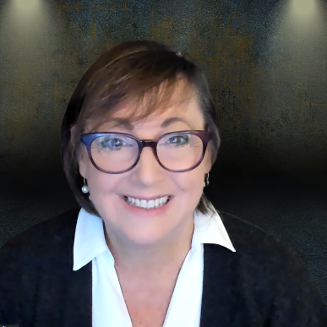

Course Description

Often misunderstood, harm reduction is an evidence-based practice and strategies for reducing the harmful or negative effects from substance use disorder – a medical condition affecting more than 20 million Americans.

In this course you will learn the benefits of harm reduction and how strategies can be applied to reduce harm and further complications from drug use and reduce the harm and risks to the community. The course will dispel some common myths of harm reduction and illustrate where it fits within the continuum of substance use disorder (SUD) treatment and recovery. Participants will gain an understanding of harm reduction principles and services and will be able to define what it means to “practice” harm reduction.

Course Objectives

After completing this course, the participant will be able to:

1. Define harm reduction as it is used in engaging people who use drugs into services and support.
2. List a minimum of three benefits of harm reduction for the individual and/or community.
3. Recognize an effective Harm Reduction practice in contrast to a practice which does not apply harm reduction principles to the services/tools.

Speaker Information

**Kourtnaye Sturgeon** is the Director of Education at Overdose Lifeline, Inc. (ODL), an Indiana nonprofit dedicated to helping individuals, families, and communities affected by the disease of addiction/substance use disorder through advocacy, education, and support.

Kourtnaye worked for twenty years for a leading global education company and joined Overdose Lifeline in 2015 - helping to develop adult continuing education and training programs and a youth opioid education program. Today, Kourtnaye works with more than 800 partners in 33 U.S. states using one or more of ODL’s education programs.

**Target Audience: PTA, PT, Students**

**SESSION 2****: Staying True to Your Purpose and Avoiding Burnout: Your Roadmap to Guide You to a Fulfilling Career**

*Speakers: Bryan Bourcier, PT, DPT, ATC, Board-Certified Clinical Specialist in Sports Physical Therapy*

*Thomas Ruediger PT, DPT, DSc, Board-Certified Clinical Specialist in Orthopaedic and Sports Physical Therapy*

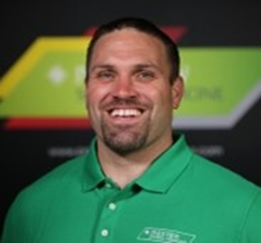

Course Description

We became PTs/PTAs to make meaningful differences in our patients' lives. You are entering a health care climate of decreasing reimbursement and increased restrictions; often student loan debt adds more complexity to your career choices. It is easy to get bogged down in the reality of continually working harder for less financial return. We will walk you through how to embrace WHY you are a PT/PTA, to make purposeful career choices to stay inspired in your work and fulfilled. This session is designed for the students and new professionals to develop a custom roadmap to guide your career choices and growth so that you come to work inspired, feel safe at work, and go home energized and fulfilled.

Course Objectives

After completing this course, the participant will be able to:

1. Verbalize their professional growth plan.
2. Understand their working strengths and frustrations.
3. Develop their “why” statement to find what fulfills and inspires them.
4. Create a plan as they identify opportunities to align their purpose with their career.

Speaker Information

**Bryan Bourcier PT, DPT** is an ABPTS Board-Certified Sports Clinical Specialist, a Certified Orthopedic Manual Therapist, and a Certified Athletic Trainer. In 2020, Bryan started a process of changing culture in outpatient therapy and has been on that journey since. The Manager of Parkview Outpatient Therapy since 2013, Bryan founded Parkview Health Physical Therapy Residencies (Sports, Neuro, and Women’s Health) and serves as Residency Director. Bryan co-created and co-owned Athletes With Purpose LLC (AWP), a sports performance company in northeast Indiana from 2006-2018. Bryan served as Chief Product Officer until 2012, and Chief Education Officer from 2013-2018. Athletes training under AWP achieved 200+ college scholarships and 11 are professional athletes. Bryan graduated from the University of Indianapolis in 2004 (Athletic Training) and 2007 (DPT). Bryan is active in APTA, in 2019 won the Anthony D. Certo Award, and currently serves on the Board of Directors as the Northern Districts Director at Large.

**Thomas Ruediger PT, DPT, DSc**, is an ABPTS Board-Certified Sports Clinical Specialist and Orthopaedic Clinical Specialist, and a Certified Orthopedic Manual Therapist. For 13 years he has held a full-time teaching position, 6 years at the University of Michigan – Flint, 7 years at Trine University. He has practiced as a direct access provider in the U.S. Army, outpatient Physical Therapy (hospital and PT owned), home health, and cash-based private practice. His current practice consists of sports performance enhancement, primarily for distance runners. He is a Sports Residency Clinical Mentor. Tom is a graduate of The US Army-Baylor University Physical Therapy Program (MPT 1998), Rocky Mountain University of Health Professions (DSc 2009), University of Montana (DPT 2014). Tom has been a member of the Specialty Academy of Content Experts of the American Board of Physical Therapy Specialists since 2010 where he has a current appointment on the Committee of Content Experts.

**Target Audience: Students and New Professionals**

**SESSION 3****: ETHICS & INDIANA JURISPRUDENCE**

*Speakers: Emily Slaven, PT, PhD, Board-Certified Clinical Specialist in Orthopaedic Physical Therapy*

*Carol Krueger-Brophy, PT, JD*

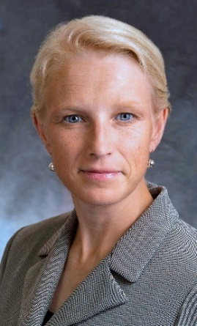 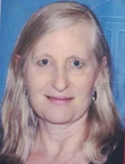

Course Description

This course on Indiana Physical Therapy Ethics and Jurisprudence is designed to provide a review of the ethical and legal standards that provide a basis for professional practice in Indiana. The new provisions in the Indiana Practice Act related to telehealth and the Physical Therapy Compact are reviewed. A description of the concepts of non-maleficence, beneficence, autonomy, fidelity, veracity and justice in medical ethics are discussed and the individual and cultural differences that influence ethical practice are described. APTA core values, Guide for Professional Conduct, APTA Code of Ethics for the Physical Therapist and Standards of Ethical Conduct for the Physical Therapist Assistant serve as resources for this presentation. Clinical scenarios are used to assist clinicians in applying the resource documents to determine appropriate ethical behavior and provide an opportunity for self-reflection.

Course Objectives

Participants will learn:

1. Define the medical ethics concepts of non-maleficence, beneficence, autonomy, veracity, fidelity, and justice.
2. Apply the current APTA Code of Ethics for the Physical Therapist, Standards of Ethical Conduct for the Physical Therapist Assistant, and APTA Guide for Professional Conduct in clinical scenarios to achieve ethical outcomes.
3. Differentiate between legal and ethical principles in analyzing ethical dilemmas and/or case scenarios.
4. Access current resource documents on the APTA website related to ethical practice of physical therapy.
5. Understand the 2021 changes to the Indiana Physical Therapy practice act and how the new law impacts practice in Indiana.

Speaker Information

**Emily Slaven** has been a practicing physical therapist for over 25 years. In 2011 Emily joined the faculty at the University of Indianapolis and is now an Associate Professor in the Krannert School of Physical Therapy. Additionally, Emily practices at Franciscan Health in Mooresville, Indiana. Emily has served in many roles in APTA Indiana ranging from District leadership up to her current role as Chapter President which she has held for the past five years. Emily testified in 2013 during the legislative efforts to obtain direct access and again during the 2019 Legislative session. Emily has been a member of the APTA Indiana State Legislative Committee for the past 3 years.

**Carol Krueger-Brophy** has been a practicing physical therapist for over 35 years, treating patients with neurological disorders, with a particular concentration in geriatrics and vestibular disorders. She works as an outpatient therapist at Franciscan Health in Lafayette, IN. Carol has a BS in PT from Oakland University and a JD from the University of Michigan School of law; she is an adjunct faculty member at the Loyola Chicago Beazley Institute for Health Law and Policy. She has a particular interest in the intersection of law, medicine and ethics. Carol taught Ethics to physical therapy students at Belmont University for 17 years and has taught courses in ethics and jurisprudence to practicing and student physical therapists. She has served on hospital and state chapter Ethics committees and is presently a member of the APTA Indiana Ethics Committee.

**Target Audience: PTs, PTAs**

**SESSION 4: Physical Therapy Meeting the Challenge of the Opioid Epidemic Using a Population Health Perspective**

*Speakers: Steven Kinney PT, DPT, Board Certified in Orthopaedic Physical Therapy, Certified Strength and Conditioning Specialist*

*Janet Delong PT, DPT, MHS, MSW, Cert MDT*

*Mary Beth Genday, PT*

*Hannah Bernhardt PT, DPT, ATC*

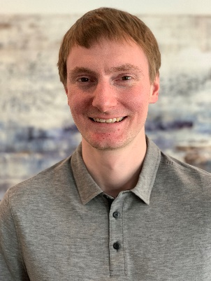 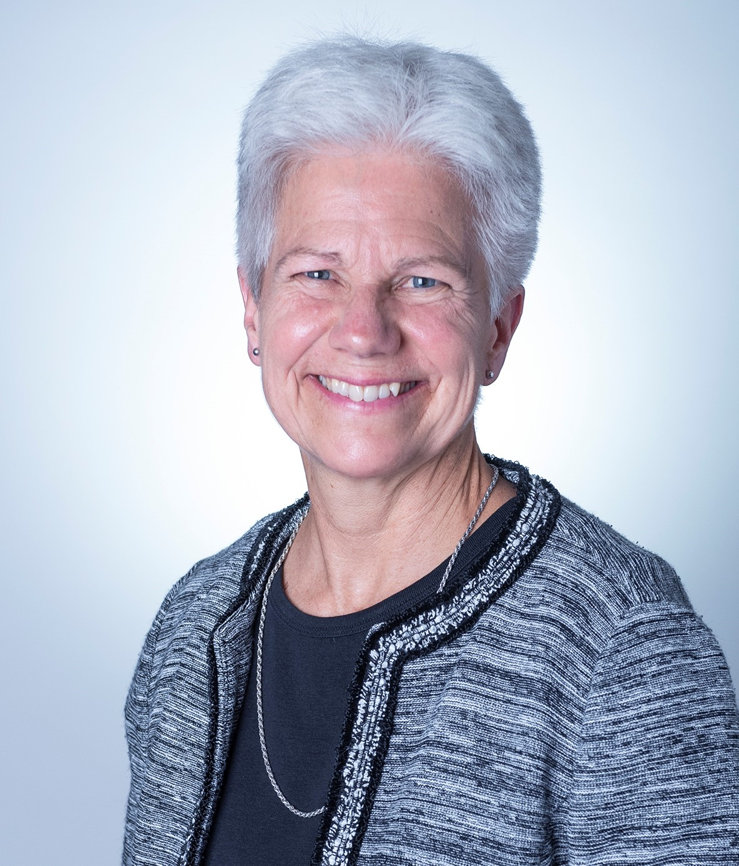 ** 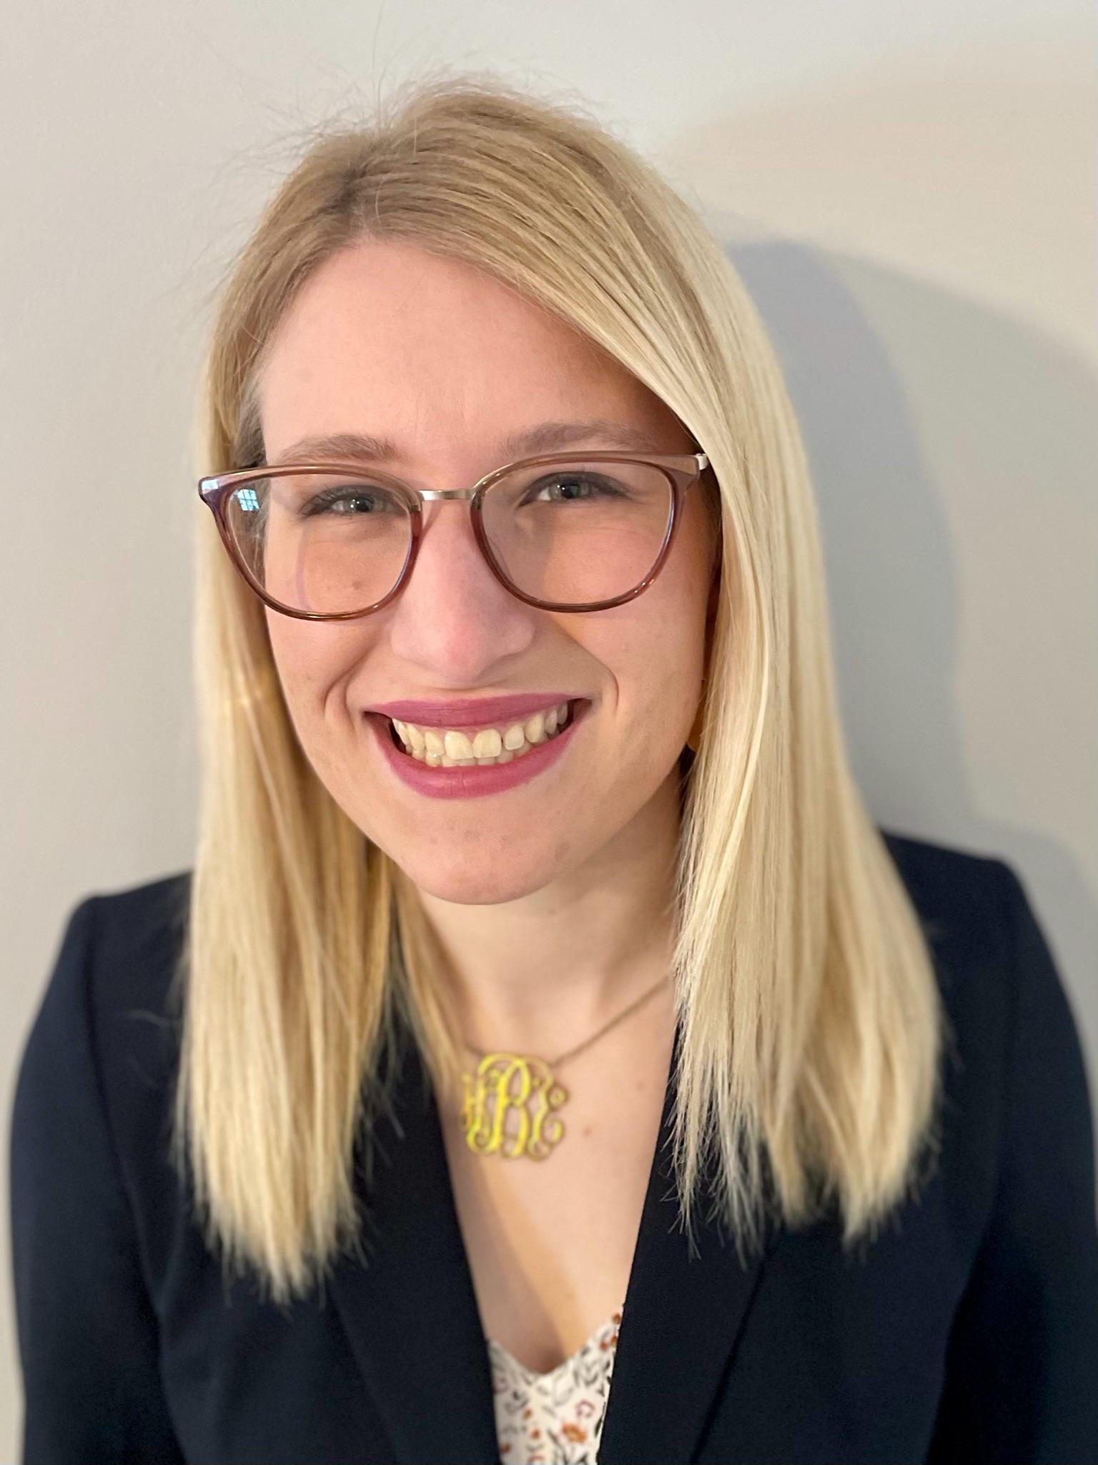

Course Description

The opioid epidemic remains a public health emergency. Recent evidence suggests this epidemic may only be getting worse. Due to its scope and severity, multiple, multifactorial solutions are necessary. Physical therapy providers have a major role in these solutions. Already, the research shows physical therapy providers reduce opioid use, though additional opportunities exist for physical therapy providers to meet this challenge.

This session will utilize a population health perspective, showing various ways physical therapy providers prevent, reduce, and limit opioid use. Each speaker will highlight different strategies using lecture and discussion. Clinical management of complex presentations will be a focus. Patient experience, therapeutic alliance, heart rate variability, individualized exercise prescription, and autonomic response to persistent pain and opioid use disorder will be emphasized. Additionally, the role and implementation of prevention strategies will be integrated. Considering and addressing upstream factors such as the social determinants of health will also be discussed.

Course Objectives

After completing this course, the participant will be able to:

1. Understand how a population health framework applies to the opioid epidemic.
2. Utilize evidence-based clinical management for patients with pain or using opioids.
3. Implement prevention strategies to address the opioid epidemic.
4. Integrate the assessment and treatment of upstream factors in individuals affected by the opioid epidemic.

Speaker Information

**Steven Kinney** has practiced in outpatient, subacute rehab, home health, inpatient rehab, and acute care hospital settings with diverse patient populations. He enjoys using an integrated approach to serve the varied needs of his patients. He is also a lab instructor and guest lecturer at Indiana State University. He has taught and developed continuing education courses for physical therapists and other healthcare professionals at the state and national level. Steven currently serves as the Chair of the APTA Indiana Pain Special Interest Group.

**Janet DeLong** has a diverse background in physical therapy and mental health care, having practiced in various settings as a Doctor of Physical Therapy, Licensed Social Worker, and Nationally Board-Certified Health and Wellness Coach. She is a Training Specialist and Research Associate for Prevention Insights at Indiana University, owner of Delong Wellness, LLC, and teaches Health and Wellness Coaching and Co-Occurring Disorders: Mental Health and Substance Use for Indiana University, and Health Behavior Coaching for Ivy Tech. Janet has a passion for working with persons who manage persistent pain, who have experienced trauma, who have issues around mental health and substance use and/or who are oppressed in some way. She provides education on Motivational Interviewing and other counseling/ communication tools, persistent pain and wellness, and is interested in prevention on both an individual and a societal level. Janet is a member of the Motivational Interviewing Network of Trainers, the American Physical Therapy Association, and the National Association of Social Workers.

**Mary Beth Genday** has been a practicing PT for 32 years. After getting a BS in Nutrition Science from Penn State, she went on to get another BS in Physical Therapy from University of Texas Southwestern Medical Center. Her PT journey has included 6 states and Canada and her patient populations include ortho, neuro, pediatrics, amputees, acute care, school system, burn, long term care, and pelvic health. Though she never specialized, she did find patterns in her patient populations: the co-existence of fear and elevated SNS and pain/dysfunction. Studying research helped Mary Beth find evidence for the correlation of trauma, PTSD, anxiety and chronic pain. Thanks to some of the great PTs who do work with the diaphragm, she began to incorporate the “script” and the techniques described in her course description with much success. She has addressed the role of the PT for victims of trauma at Indiana Coalition to End Sexual Assault (ICESA) in April 2020. She also speaks to physician groups on pediatric aspects of care and provides in-services for local schools on techniques they can use to improve the autonomic nervous system in children.

**Hannah Bernhardt** is a new graduate and current orthopedic resident at Forefront Therapy in Evansville, IN. She is a Certified Athletic Trainer and also holds certifications in SFMA Level 1 and LSVT BIG. As a PT student at the University of Evansville, she was the coordinator and session leader of ACErcise, a probono fitness class for clients with neurological disorders. She has developed an interest in treating chronic conditions and persistent pain through her clinical experiences at the University of Evansville in Athletic Training and Physical Therapy as well as her personal experiences with persistent pain.

**TARGET AUDIENCE: PT/PTA (LEVEL – INTERMEDIATE)**

**SESSION 5****: Rethinking the Tools in the Toolbox? Evidence-based Strategies to**

**"Move Forward" in Neurological Rehabilitation**

*Speakers: T. George Hornby PT, PhD*

*Lindsay Shoger, PT*

*Jenny Lotter, PT*

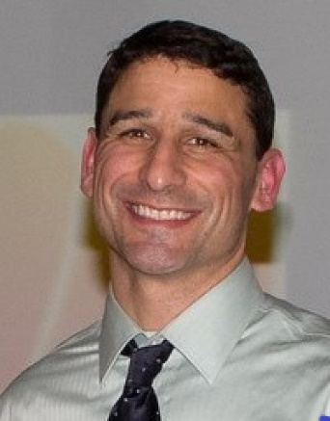 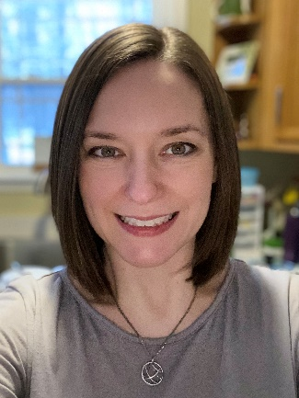 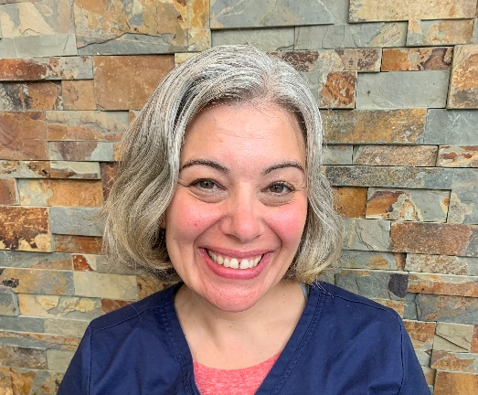

Course Description

The recent Academy for Neurologic Physical Therapy position paper emphasized the continuing efforts to support the use of evidence-based exercise interventions applied to patients with neurological injury. This position was directed towards more traditional interventions (NDT, PNF, Neuro-IFRAH) utilized in the clinical setting for decades despite the lack of evidence to support their efficacy, but also to recently developed strategies that were initially promising but also challenged by the lack of positive evidence. The Moving Forward Task Force has been directed to develop resources to help clinicians embrace the use of more effective, evidence-based interventions. Implementation of these new “tools” should be accompanied by efforts to de-implement less-effective strategies, which may be daunting give the desire of PT to embrace traditional theories and strategies.

This symposium will discuss the efforts of the ANPT Moving Forward Task Force to rethink the tools in the toolbox of neurological rehabilitation. We will provide an overview and rationale for development of the ANPT position paper, followed by discussion of the utility of specific “tools” available in clinical practice. This discussion will focus both on practice patterns that were originally theorized to improve function, but have subsequentially been shown to be less effective than expected, but also on more-effective, established interventions or new strategies with greater promise. Activities of the Moving Forward Task Force will be described, with identification of resources for both implementation and de-implementation in the clinical setting.

Course Objectives

After completing this course, the participant will be able to:

1. Provide an overview and describe the rationale for the ANPT Moving Forward position paper.
2. Identify specific traditional theories and common practice patterns and the data supporting their utility.
3. Discuss more recent strategies with substantial evidence and how to reconcile evidence-based strategies with traditional or emerging interventions.
4. Delineate efforts of the Moving Forward Task Force to provide resources and strategies to implementation evidence-based practices and de-implement less-effective interventions.

Speaker Information

**T. George Hornby PT, PhD**, is a Professor of Physical Medicine and Rehabilitation at Indiana University and the director of the Locomotor Recovery Laboratory at the Rehabilitation Hospital of Indiana.  Dr. Hornby’s work is focused on optimizing rehabilitation interventions to improve lower extremity function in patients with brain and spinal cord injury, with a primary focus on restoration of walking ability.   By integrating both quantitative and clinical measures of motor function, Dr. Hornby’s work aims to understand the biomechanical and physiological impairments underlying limitations in locomotor activity in these populations, and efficacy and mechanistic basis of specific interventions to enhance function.  HIs activity has focused on direct translation of his research to clinical practice in rehabilitation. Dr. Hornby has co-authored over 100 research publications in scientific journals. He is PI or Co-PI on active R01, DOD, and NIDILRR center grants, and co-owner of the Institute of Knowledge Translation.

**Lindsay Shogur, PT**, is a clinical physical therapist on the Brain Injury Unit at the Rehabilitation Hospital of Indiana and a research therapist at the Locomotor Recovery Laboratory. She is lecturer for Indiana University Department of Physical Therapy in their neurological curriculum. She is currently workings towards her NCS through the Institute of Knowledge Translation (IKT)>

**Jenny Lotter, PT**, is a clinical physical therapist on the Stroke Unit at the Rehabilitation Hospital of Indiana and a research therapist at the Locomotor Recovery Laboratory. She is a member of the Moving Forward Task Force with the Academy of Neurologic Physical Therapy. She is currently working towards a Doctorate in Health Science at the University of Indianapolis.

**TARGET AUDIENCE: PT/PTA (LEVEL – INTERMEDIATE)**

**SESSION 6: Leaders Are Made, Not Born: How to Succeed with Personnel Management**

*Speaker: Brian Gallagher, PT*

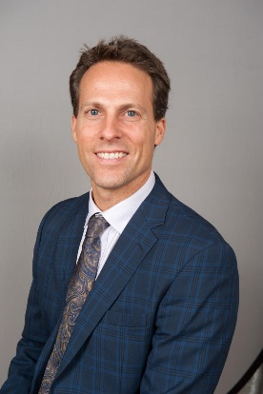

Course Description

Many physical therapists go into private practice thinking that being a good clinician is the qualification for being a great owner. As a new owner, there will be situations and unique circumstances that PT school never prepared you for. A major one being the need to align your goals and purposes with your staff’s. It’s never the actual practice of physical therapy that will bring you pause, but rather the management of others. Our session will not simply discuss bright ideas, but will give you real application of specific skills to establish you as a great leader who can create positive change. The result will be greater certainty through more effective communication, a stronger company structure, innovative systems of operations, and a healthy company culture. Your takeaway: knowing how to be an effective leader through better communication, gamification and a sense of personal value contributing to the company’s overall cause.

Course Objectives

After completing this course, the participant will be able to:

1. Implement a streamlined practice structure that enhances efficiency, resulting in greater productivity.
2. Formulate more effective policies & procedures that better represent the needs of patients and personnel of today’s workforce.
3. Develop a plan of proven effective leadership strategies that you can implement immediately.
4. Apply the technique of “Role Play” to enable mastery of the soft personnel management skills taught.

Speaker Information

In 1997, Brian founded one of Maryland’s largest therapy staffing companies, while simultaneously launching a multi-site private practice which resulted in a sale in 2006. Brian re-acquired the practice in 2008, thus doubling it, before winning “Practice of the Year” in 2011. MEG Business Management began in 2006 as an educational coaching company training owners and their key employees on innovative practice management strategies. MEG has taken a major leap forward by developing a Virtual Training platform where practice owners now have the tools & training resources to professionally enhance, track and manage employee performance & compliance. MEG also provides leading PT Billing solutions, Credentialing services and website design support for Marketing. When Brian is not coaching or working on the training platform, he can be found giving lectures at APTA, PPS and CSM Annual Conferences, as well as APTA State Chapters and DPT Schools across the country.

**TARGET AUDIENCE: PT/PTA (LEVEL – INTERMEDIATE)**

**SESSION 7: Promoting and Implementing Direct Access & Early Access Physical Therapy:**

**A Panel Discussion**

*Speaker and Panelists: John Kiesel PT, DPT, Board-Certified Clinical Specialist in Orthopaedic Physical Therapy*

*Ryan Wood, PT, DPT, MHA, Board-Certified Clinical Specialist in Orthopaedic Physical Therapy*

*Kelly Clark, DPT, PT, MT*

*Bryan Bourcier, PT, DPT, Board-certified Sports Clinical Specialist, Certified Orthopedic Manual Therapist, ATC*

*Stephanie Yoder, PT, DPT*

 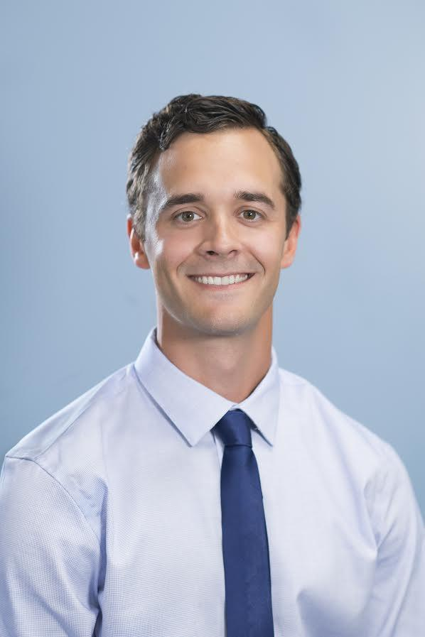 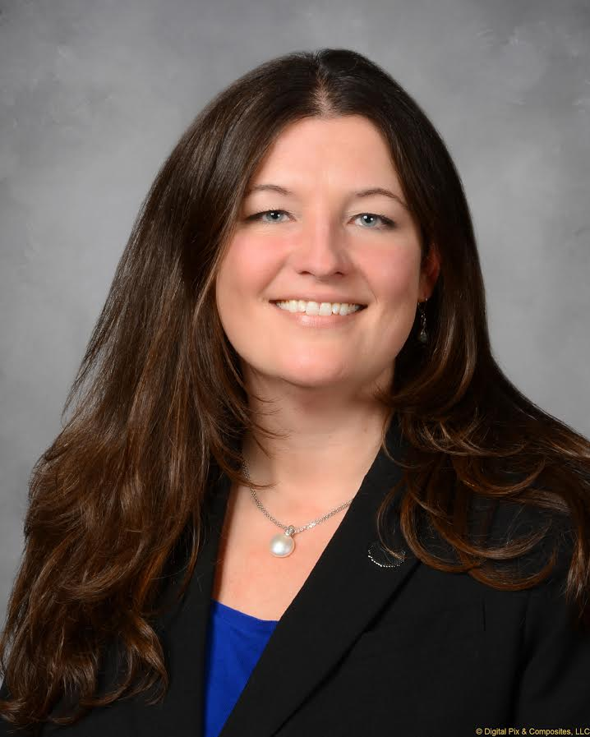 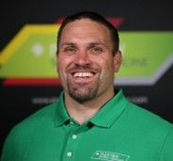 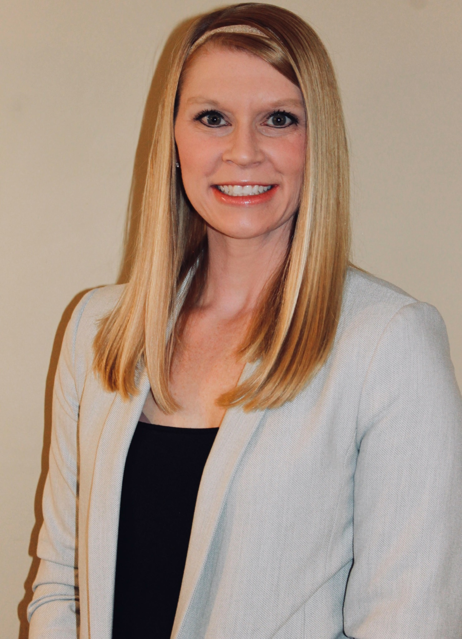

Course Description

This session will be a panel discussion with physical therapy professionals who are successfully using and promoting direct access & early access to PT in their setting. The attendee can expect discussion on marketing and advertising practices, interprofessional communication, and ideas on navigating barriers to the implementation of direct access/early access in different practice settings. This will be an opportunity to learn from the people who are successfully moving their organizations forward by using direct access/early access to physical therapy. This session will be interactive and will allow for audience questions to panelists.

Course Objectives

After completing this course, the participant will be able to:

1. Identify successful PT professionals in regards to promoting and implementing direct access.
2. Recognize the individual role of PT professionals in the promotion of direct access.
3. Explain strategies for overcoming common barriers to the implementation of direct access.
4. Differentiate best practices for marketing direct access services.
5. Design strategies to promote direct access within your practice setting.

Speaker Information

**John Kiesel** works as an assistant professor at Indiana State University in the Doctor of Physical Therapy program. He maintains a clinical practice as a physical therapist in an outpatient orthopedic setting. He is completing his PhD in Teaching & Learning. His research interests include training healthcare providers to be better equipped to treat pain using active interventions, education, and counseling. He has a particular passion for translating the current evidence on our understanding of pain to reduce the burden of pain on society and optimize how we treat individuals in pain.

**Panelists** - Ryan Wood, Kelly Clark, Bryan Bourcier, Stephanie Yoder

**Ryan Wood** is co-owner of for-profit branch Forefront Therapy, LLC and President/CEO of nonprofit branch Forefront Community Therapy, Inc. Their organizations rely heavily on direct access with 90% of their caseload in their founding year being direct access. Now in year 5 with considerable growth, they still have a heavy direct access presence with 50% of their caseload being direct access. He is the onsite mentor for their Orthopedic Physical Therapy Residency and has a passion for complex presentations in the Orthopedic realm.

**Kelly Clark** is owner and founder of Patient PT, a sole provider direct pay PT clinic in Bloomington Indiana. She specializes in treating patients with persistent pain conditions from a wellness, health literacy, and preventative maintenance standpoint. Dr. Clark is dual-licensed as a physical therapist and massage therapist, and she offers both traditional physical therapy services and elective manual therapy treatments. Virtually all her clients are direct access, and her marketing is exclusively direct-to-consumer. Her pro-bono therapy program, Pain MAP, provides up to six weeks of free wellness care to any applicant with a household income below $60,000 and an active persistent pain condition. Dr. Clark is an APTA Indiana Centennial Scholar, and has been recognized with the Shelia Evans Health Hero Award, the Unmasked Hometown Hero Award, The Steve Warren Hero Award, and the Be More Bloomington Award for her community organizing efforts in response to the COVID19 pandemic.

**Bryan Bourcier** has been the Manager of Parkview outpatient therapy since 2013. He graduated from the university of Indianapolis in 2004 with a bachelor’s in athletic training and again in 2007 with a Doctorate in Physical therapy. Over the last 13 years he has worked primarily with rehabbing athletes of all levels of athletes from amateur and youth to professional and Olympic. Bryan has certifications as a Certified Orthopedic Manual Therapist (COMT) in 2008, and in 2019 became a Board-Certified Sports Clinical Specialist (SCS) from APTA. Bryan also co-created and co-owned Athletes with Purpose LLC (AWP). A sports performance company in northeast Indiana from 2006-2018. Bryan served as the Chief Product Officer until 2012, and then the Chief Education Officer until 2018. Athletes training under the AWP program achieved over 200 college scholarships and the program also helped produce 18 professional athletes. Bryan was the founder of the Parkview Health physical therapy residency programs and currently serves as Residency Director for their Sports, Neuro, and Women’s health residencies. In 2020, he started a process of changing culture in outpatient therapy and has been on that journey since. Bryan has also been active in APTA and in 2019 won the APTA Indiana Anthony D. Certo Award to recognize and honor his contribution of time, energy, and expertise toward furthering physical therapy as a professional practice. He currently serves as the APTA Indiana Director at Large for the Northern Region.

**Stephanie Yoder** graduated with her bachelors in Movement Science from the University of Evansville in 2009. She then went on to receive her Doctorate in Physical Therapy in 2011. Stephanie began working as an acute care physical therapist at IU Health Bloomington Hospital in June of 2011, and has served as an APTA Certified Clinical Instructor for the last 9 years. Stephanie has collaborated with multidisciplinary staff to improve direct patient care via the Falls Prevention Committee, the ICU Early Mobility Team, and the Progressive Mobility Council. Stephanie resides in Bloomington with her husband and three young sons.

**TARGET AUDIENCE: PT, PTA, STUDENTS**