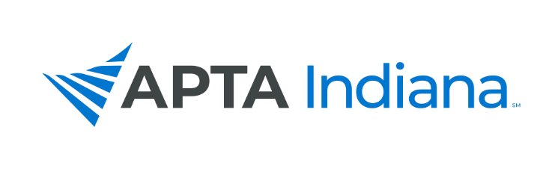
2021 ANNUAL REPORT

Board/Committee/SIG Position: Vice President Report

Name: Nathan Nevin, PT, DPT, OCS, FAAOMPT

APTA INDIANA STRATEGIC PLAN UPDATE FOR TRACKING SHEET
GOAL & STRATEGY # | UPDATE
Goal #2, Strategy 1 | The focus for this year’s conference was to work on creating an in-person event for the first time since 2019. Last year’s conference had to go virtual. The conference committee has continued to meet and communicate throughout the year and has finalized all sessions, accepted and given feedback to poster proposals, and has worked with Suzie to fill all jobs for the weekend of the conference. Post conference, the committee will communicate to brainstorm ideas to grow the conference next year.
Goal #2, Strategy 2 | We have started some discussion with possibly combining Sports Section conference with Indiana Fall Conference next year. We have not had any conversations with other states for combined conference, but Kentucky has suggested that they would be more than open to combine conferences again in the future. The goal will be to create more discussion with the Sports Section with the conference committee and possibly reaching out to surrounding states Illinois, Michigan, and Ohio for possibly opportunities to collaborate.

INCLUDE ADDITIONAL INFORMATION NOT RELATED TO THE STRATEGIC PLAN HERE

Vice President Report

- Over the past year, I have worked closely with Suzie and Emily and also the Board. My goal was to support Emily and assist her with her workload throughout the year.
- My main role as Vice President has been to work with the Conference Committee and Suzie to host the Fall Conference.
- The Conference Committee was created earlier in the year, and we had two Zoom meetings and discussed all other matters via email.
- We worked to accept all session proposals and poster proposals over the past few months.
- I have had biweekly phone calls with Suzie and Emily to discuss any topics, issues, or projects.
- I also worked as the Centennial Celebration Ambassador for Indiana.
  - We hosted a virtual celebration for APTA’s 100th Anniversary
  - Created the Centennial Celebration Exercise Challenge, trying to create engagement while promoting movement.
  - Created the pledge for 100 members serving Indiana for PT Day of Service, closing out 2021.
  - Created a selection committee to select our two Centennial Scholars and have worked to support them throughout their capstone.
- It has been a pleasure working with the board and serving as the APTA Indiana Vice President for 2021.

Awards Committee

- Chapter Student Scholarship awarded for SPT and SPTA.
- Awarded both PT Specialist Certification Scholarships.
- No applicants for PTA Advanced Proficiency Scholarships.
- Awarding Emerging Leader, Schneider, Flesch, Certo and Ekstam Awards for 2021. No nominations for Rosenbaum.

Conference Committee – See Above Information From Nate Nevin

Continuing Education Review Committee

- Income from CE Reviews: As of 8/31/21 - $22,740 in CE Review Application Income.

- Amount Paid to Reviewer for Review of Applications: As of 8/31/21 - $1,630 Reviewers.

- Applications: As of 8/31/21 – Received 299 applications in 2021 so far.

- Number of Current Reviewers is Back to 4.

