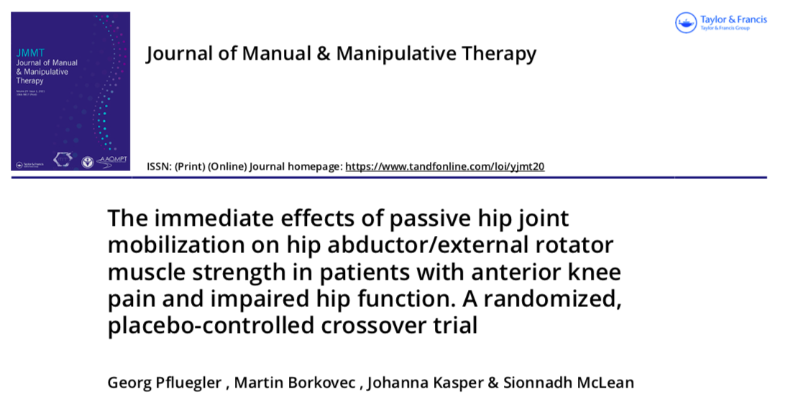
Links: https://doi.org/10.1080/10669817.2020.1765625
Introduction:
Individuals experiencing anterior knee pain often demonstrate hip weakness, specifically, hip abductors, extensors and external rotators. While many studies have correlated the use of passive, low-velocity hip mobilizations to an increase in muscle strength, no studies have looked specifically at the effects of passive, low-velocity hip mobilizations on anterior knee pain. The researchers studied the effects of a passive grade III anterior to posterior hip mobilization on patients with anterior knee pain that also showed deficits in hip abduction strength, external rotator strength, and passive hip range of motion.
Methods:
Each participant received both the intervention and the placebo treatment in random order. In both groups, the pt was supine with a knee roll. During the intervention session, the participant received a passive rhymical grade III anterior to posterior hip mobilization for four minutes. This was followed with an additional minute of a grade III hip mobilization that was chosen specifically for each participant depending on their most limited hip movement. The placebo treatment received four to five minutes of a grade one anterior to posterior mobilization. Eccentric hip abductor/ external rotator strength was measured before the treatment and immediately following the treatment.
Results:
There was an increase of 7.73% in hip abductor and external rotator strength immediately following the intervention treatment and a decrease of 4.22% in strength following the placebo treatment. 17 out 18 participants did not have pain during strength testing; 1 presented with mild pain during hip abductor and external rotation strength testing.
Relevance:
This study lends support that passive grade III hip mobilizations have an immediate impact on eccentric hip abductor and external rotator strength in pt’s presenting with both anterior knee pain and impaired hip ROM. This leads to the idea that using passive grade III hip mobilizations for these patients before muscle performance exercises will have a positive impact on strength performance.

