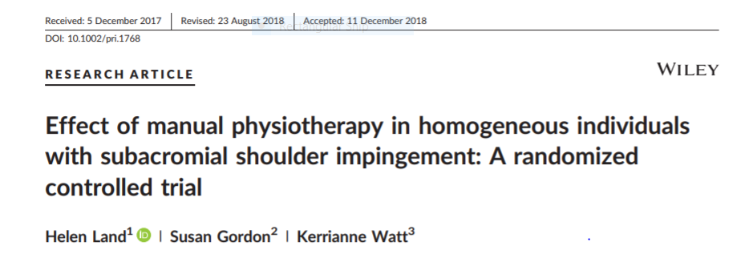

Links
http://web.a.ebscohost.com/ehost/pdfviewer/pdfviewer?vid=1&sid=5c4e7667-f470-4906-acd3-c2bd211f871b%40sdc-v-sessmgr01

Introduction
Subacromial shoulder impingement (SSI) is a common condition for which patients present to PT, usually in conjunction with a positive Neer and/or Hawkins-Kennedy test. Common outcome measures used to measure effectiveness of interventions include pain with VAS, SPADI or DASH, and other subjective measures, but few studies measured objective measures. One study noted that people with SSI had increased resting thoracic flexion, as well as significantly reduced active upper thoracic flexion/extension motion, and reduced passive posterior shoulder range vs controls. Authors report no other studies investigating the effects of interventions that increase thoracic ROM or posterior shoulder ROM. The aim of this study was to compare the effect of (1) passive mobilization to the upper thoracic spine; (2) massage, passive mobilization, and stretching to the soft tissues of the posterior shoulder; and (3) an active control intervention, on pain, function, and ROM in a homogeneous SSI group. The authors hypothesized that there would be a significant improvement in pain, function, and ROM in the groups receiving passive mobilization interventions vs the active control group.

Methods
All 3 treatment groups had treatment for initial 6 consecutive weeks- first 3 weeks were 2x/week, second 3 weeks were 1x/week. Then finished 6 more weeks of just HEP. Reassessed at week 3, 6, 9, and 12, then 6 months later. All interventions performed by same 2 PTs, reviewed/trained to be consistent.
Active control group used US. Upper thoracic group used grade III transverse and costovertebral mobilizations (T1-6) on the side of the painful shoulder for 20 min treatment time; home program was lying supine with longitudinal towel roll in thoracic spine for 5 mins, 2x/day. Posterior shoulder group used posterior soft tissue massage, specifically infraspinatus and teres minor, for 15 mins, positioned on asymptomatic side; also used grade III AP glides to glenohumeral joint in supine for 2 mins. Home program was passive cross adduction stretch in standing, 2x20 sec, 2x/day. Compliance monitored by exercise diary for both groups.

Results
Upper thoracic and posterior shoulder interventions, with targeted HEP, both significantly decreased pain and increased function scores and increased posterior shoulder ROM in people with SSI compared to active control. Neither group showed a greater degree of benefit.
Significant improvement in SPADI scores, passive IR, and posterior shoulder ROM was found between baseline and week 6. Subjects maintained improvements (reduced pain, improved function, objective increase in passive IR) at 12 weeks with cross-body stretch and home stretches for thoracic extension.

Relevance
This study provides evidence that patients can make objective improvements in passive IR and posterior shoulder ROM that are clinically meaningful, as well as subjective improvements in function, with manual therapy treatment that addresses the extrinsic contributing factors such as decreased thoracic spine mobility or posterior shoulder ROM. This study chose to prescribe only one home exercise specific to the maintenance of gains from the intervention provided, suggesting that a targeted exercise may achieve a similar benefit.
Mobilization of upper thoracic spine or massage and mobilization of posterior shoulder structures combined with targeted home exercise, in a homogeneous group with extrinsic SSI, significantly improves function and passive IR ROM. Improvements continued to be significant 6 months after intervention.

