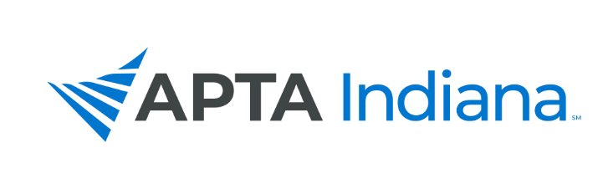

2020 ANNUAL REPORT

Board/Committee/SIG Position: Student SIG

Name: Kate Lindemann, SPT, ATC, LAT

APTA INDIANA STRATEGIC PLAN UPDATE FOR TRACKING SHEET
GOAL & STRATEGY # | UPDATE
Goal 2, Objective 3, Number 7 | There has been some consistent feedback and information given to the students via school liaisons. The SSIG has been sending newsletters every 2 months and structured bullet pointed emails of SSIG, Student Assembly, and relevant APTA information.

INCLUDE ADDITIONAL INFORMATION NOT RELATED TO THE STRATEGIC PLAN HERE

1. Social Media. As the Student SIG, we have significantly increased our representation and consistency of posting on both twitter and Facebook. This has increased our presence and the number of views of both current SPTs and DPTs.
2. Listserv. Since, we have gotten access to listserv we have been working on promoting to increase the number of students who have direct access to APTA Indiana information.
3. DPT and PTA School Information. We have administered a survey to all programs indicating how they currently promote APTA along with what they would like from the SSIG to help benefit their students. We have taken this information and begun trying to find ways to administer this information to both the programs and students.

