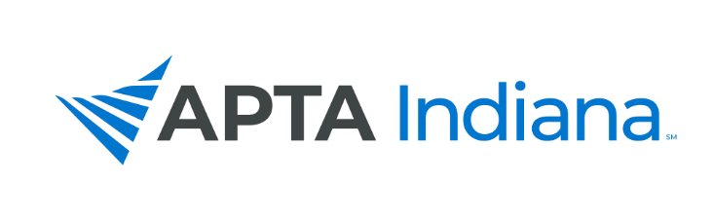

2020 ANNUAL REPORT

Board/Committee/SIG Position: Southern Region Director At Large

Name: Nathan Nevin, PT, DPT, FAAOMPT

APTA INDIANA STRATEGIC PLAN UPDATE FOR TRACKING SHEET
GOAL & STRATEGY # | UPDATE
Goal 3, Strategy 2 | I have continued to communicate with both districts through the district chair via email.
Goal 5, Strategy 3 | I will usually email the districts chairs at least one time per month or sometimes more frequently as needed with pertinent information. I pass information from district chairs to the board and then take board meeting notes and pass that information to the district chairs so they can communicate during their meetings.

INCLUDE ADDITIONAL INFORMATION NOT RELATED TO THE STRATEGIC PLAN HERE

1. Assisted the SW district in the district election process
2. I had a conference call with Emily and both directors at large from central and north and we discussed communication, the use of the HUB to improve communication and accurate information for Suzie, and ways to improve communication b/t the board and the district leadership.
3. Attended one meeting from the SW district this year and two from the SE district.
4. Worked with both districts to host virtual meetings using Zoom. Both districts successfully held virtual meetings. Leadership from both districts have shown interest in continuing to utilize some form of virtual meetings in the future.

Respectfully submitted by Nate Nevin, PT, DPT, FAAOMPT

