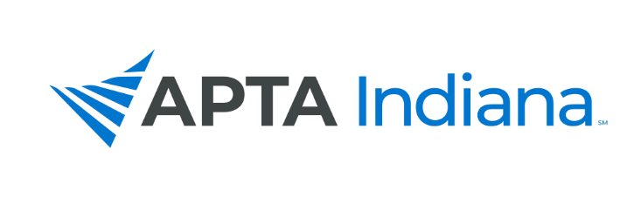

2020 ANNUAL REPORT

Board/Committee/SIG Position: PAC Chair

Name: Brad Shupe

APTA INDIANA STRATEGIC PLAN UPDATE FOR TRACKING SHEET
GOAL & STRATEGY # | UPDATE
- Advocacy – PAC Fundraising | Golf Outing canceled due to COVID-19 concerns. Most of the money generated at this event has historically come from sponsorship. We had very poor response to sponsorship due to financial impact of COVID-19. We decided to postpone the event in to next year.
Advocacy – PAC Fundraising | Holding our annual PAC auction at the virtual fall conference on Saturday September 26th. We have many great items and are hoping for a great turnout.
Advocacy – PAC Fundraising | Holding virtual Trivia Night on Friday October 23rd. This event will be via Zoom, teams will consist of 2-4 people. Trivia will cover a broad range of topics and should be a lot of fun. Cost is $30 per team. Register for the event by emailing kherald91@gmail.com.

INCLUDE ADDITIONAL INFORMATION NOT RELATED TO THE STRATEGIC PLAN HERE

1. Happy to announce that I have a team of people working alongside me this year – an official PAC Committee! Thank you to those individuals Kevin Herald, Gabby Veldman, and Bryce Showers
2. A huge piece of advocating for the profession is sharing these events with as many people as possible. If you can’t participate, please share with as many as you can.
3.
4.
5.

