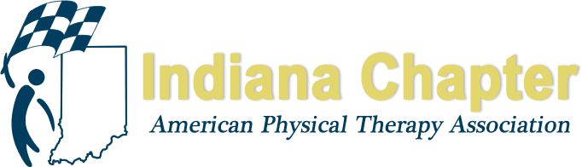

INAPTA ANNUAL REPORT

BOARD POSITION/COMMITTEE POSITION: Director at Large-Central
NAME: Ryan Cotton, PT |  | DATE: 9/2/2020
Goal #1: Advocacy
Objective #3: Strengthen the grassroots participation by engaging our members in legislative efforts
STRATEGY # | ACTION TAKEN
- Use the APTA Action App for IN legislative push | Completed 2018
- Develop CD volunteers for legislative push | Completed 2018
Goal #2: Education
Objective #1: Provide yearly continuing education to ensure quality evidence based patient care
- Districts host 2 CEU courses and state association will have 4 CEUs courses offered each year. (Leverage technology?) | Assist district and SIGs with planning and hosting course.  - CD, Peds SIG, and Ortho SIG have all hosted courses over the last year. Planning for future courses interrupted by COVID
Goal #3: Collaboration
Objective #2: Facilitate district efforts for increased member engagement
- Charge the Regional directors, vice-president, and membership secretary to establish (develop and execute/implement) a plan for net-working and education for the district leadership | - Met with CD leadership to develop strategic plan (meetings, courses, technology) for increasing membership  - CD piloted ZOOM meetings-Well received with increased attendance noted

HIGHLIGHTS FROM 2020
Central District
See CD report
Current Officers
- Josh Vice-Chair
- Hannah Enochs-Vice Chair
- Lauren Deike-Treasurer
- Rachel Milne-Sec
- Donna Peterson, Josh Weyer, Zach Pigg-Nom Committee

Communications
- Zoom meetings tested went well, reported increased attendance. Members responses liked increased flexibility to attend without travel

Ortho SIG/Peds SIG
Peds (Stasia Tapley-Chair)
- See SIG report

Ortho (Lina Avendano-Chair)
- See SIG report

