2020
COMBINED
CONFERENCE

SEPTEMBER 25-26
INDIANAPOLIS

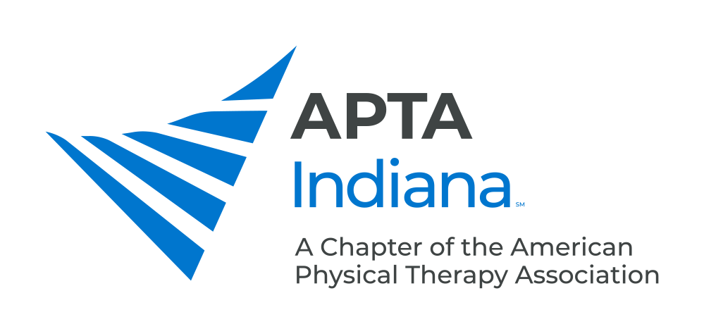
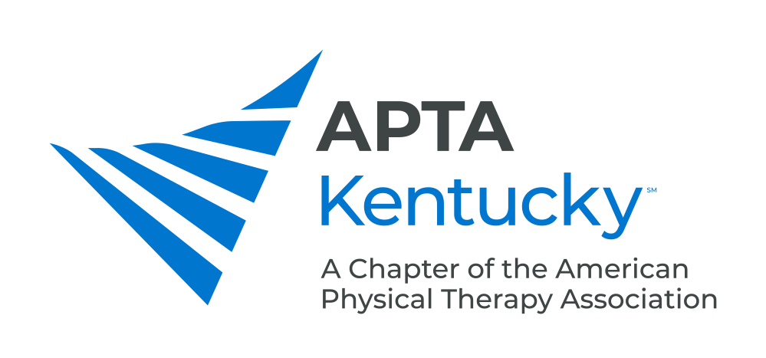

Ready to share what you know with PTs and PTAs across the state?

APTA Indiana and APTA Kentucky are Seeking Proposal Submissions for the 2020 Combined Conference

Proposals for 1.5-hour, 3-hour and 6-hour (lab) educational sessions are now being accepted.

In addition to clinical topics, we are also seeking proposals on the following:

- Programming Specific to PTA
- Programming Specific to Student PTs and PTAs
- Management
- Payment/Documentation

Proposal Submission Deadline - March 1, 2020

Proposal Submission Information:

Proposal submissions for educational sessions must contain the following:

- Title
- Course Description
- Course Objectives
- Recommended Participant Level
- Speaker Information
- Name
- Credentials
- Institution
- City/State
- Brief Bio (150 words or less) and CV for Each Speaker
- Head Shot

Important Things to Remember When Submitting Your Proposal:

- Speaker information will appear exactly as submitted in all publications both in print and online. Please ensure the accuracy of this information before finalizing your submission.
- Please indicate if your proposal is for a 1.5-hour, 3-hour or 6-hour (w/lab) educational session.
- Descriptions should not exceed 150 words.
- Selection of proposals will be based on the foundation in evidence, clarity of proposal, probable interest to participants, fiscal feasibility, and space and time constraints.
- Proposals should reflect cultural and/or ethical components related to clinical practice and research as related to session content.
- Proposals should be devoid of any promotional content.
- An honorarium of $100 per speaking hour and mileage reimbursement will be offered to accepted speakers. One-night hotel stay will be reimbursed at the conference hotel for speakers traveling over 30-miles to the conference site.

SUBMIT PROPOSALS TO INFO@INAPTA.ORG BY MARCH 1, 2020

