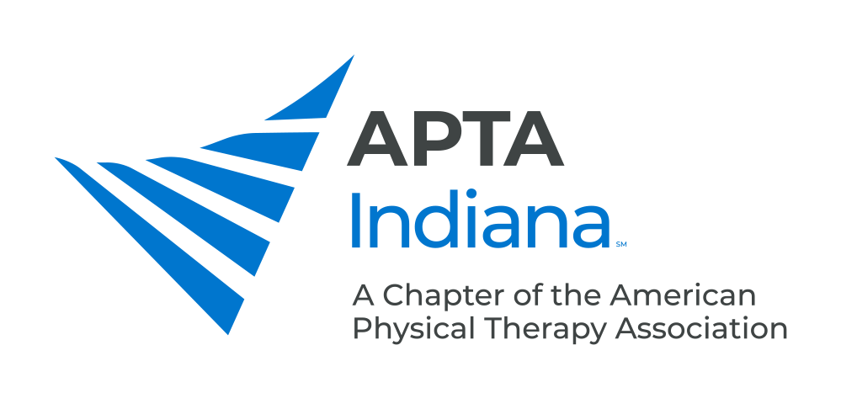

TEAM REHAB STUDENT PTA SCHOLARSHIP
These scholarships are intended to reward and encourage physical therapist assistant (PTA) students who are already demonstrating potential to be outstanding practicing clinicians. One scholarship will be awarded to a student who just completed their final year in an Indiana-based PTA program, with applications to be completed in the second year of the program.

The recipient of this scholarship will be awarded a stipend of $1,000 which will be distributed in one payment at the APTA Indiana Fall Conference Awards Banquet following the student’s recent graduation.

APPLICATION PROCESS

- Applicants will submit the following information electronically combined into one PDF:

- Cover letter describing the applicant’s career objectives and highlighting what makes him/her a team player striving for excellence within the clinical environment
- Resume
- Unofficial transcript for physical therapist assistant school only, including GPA
- One letter of recommendation from a faculty member to be sent directly via email to the Awards & Scholarships Chair Jessica Prothero at inaptaawardscommittee@gmail.com
- One or more letters of recommendation from clinical instructors to be sent directly via email to the Awards & Scholarships Chair Jessica Prothero at inaptaawardscommittee@gmail.com

- Direct questions and submit applications electronically to the Awards & Scholarships Chair Jessica Prothero at inaptaawardscommittee@gmail.com

- Applications are due by April 30

SELECTION PROCESS

Scholarship recipients will be selected by the APTA Indiana Awards & Scholarships Committee and a representative from Team Rehab. The criteria the committee will utilize includes:

- Academic success (grade point average)
- Desire to excel and practice in the clinical environment (versus teach and/or research in the academic environment)
- Contribution to customer service/patient satisfaction during clinical education
- Ability to be a team player in the clinical environment (flexibility and helpfulness to the clinical staff during clinical education)
- Evidence of advancing practical knowledge of physical therapy

