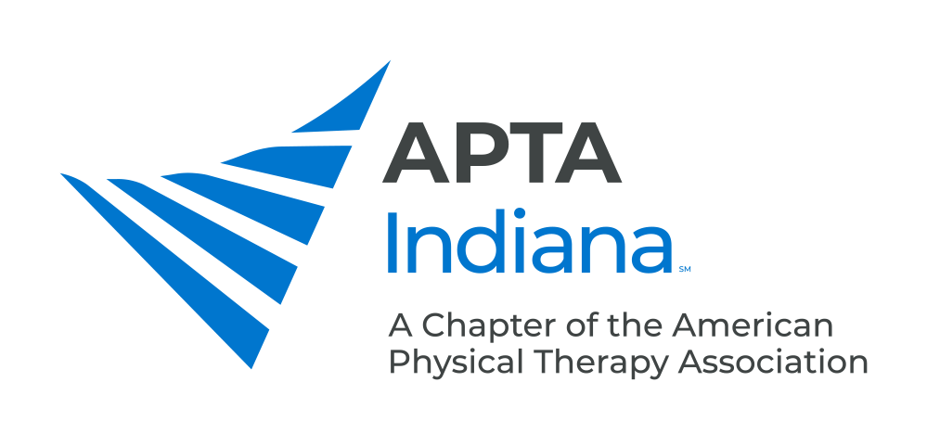

PTA ADVANCED PROFICIENCY PATHWAY SCHOLARSHIP

DEADLINE: JULY 1

APTA Indiana is pleased to award two scholarships for PTA Members who plan to pursue their Advanced Proficiency. Each scholarship will total $270, with $135 awarded initially upon acceptance and then the remaining $135 awarded after successful completion. Recipients have one year to complete the program to receive the final funds.

AWARD CRITERIA

- It is required that applicants are IN Chapter members throughout the duration of the process to obtain all scholarship funds.
- Awardees will be selected on the basis of:
  - Proof of IN licensure
  - Proof of minimum of 2 years of APTA membership
  - Proof of completion of pre-course requirements
  - Copy of enrollment application with proof of acceptance
  - Essay response related to how the advance proficiency pathway will impact your practice and professional development.

To apply, assemble a packet containing the following information:

- Completed Scholarship Application
- Copy of IN license or other verification
- Copy of APTA membership card or other membership verification
- Copy of proof of completion of pre-course requirements
  - Essay answering the question “How do you foresee a specialist certification impacting your practice and professional development?” This essay should be a maximum of two double-spaced pages in at least 10-point type.

Applicants will be notified of committee decisions by September.

Submit all materials in a single packet to:

Jessica Prothero at inaptaawardscommittee@gmail.com

PTA ADVANCED PROFICIENCY PATHWAY SCHOLARSHIP APPLICATION

Name: ____________________________________________________________________________________

Address: ____________________________________________________________________________________

____________________________________________________________________________________

Email: ____________________________________________________________________________________

Telephone: ______________________________________

APTA Member #: _________________________ Dates of Membership: ________________________________

DEADLINE: JULY 1

Direct all questions and submit all materials electronically in a single packet to:
Jessica Prothero, PT
inaptaawardscommittee@gmail.com

