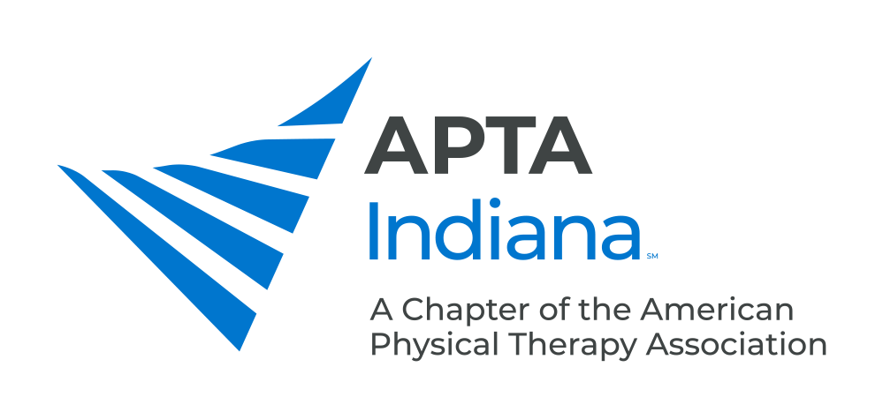

PT STUDENT SCHOLARSHIP

DEADLINE: APRIL 30
APTA Indiana is pleased to provide one $1,000 PT Student Scholarship for attendance at an APTA-sponsored conference
(CSM, NEXT or National Student Conclave) for a PT Student Member who attends an Indiana educational program.

A one-page minimum write-up describing your experience at the conference may be requested for Chapter publication.
AWARD CRITERIA

It is required that applicants are APTA Student Members.

Awardees will be selected on the basis of:
- Academic and clinical achievement in the PT program
- Community and professional service activities
- Past achievements
- Essay response

To apply, assemble a packet containing the following information:

- Completed Scholarship Application.
- Resume or Curriculum Vitae: Two page maximum, outlining education, clinical experience, work experience, community service & volunteer activities, and reference(s).
- Essay answering the question “How do you see attendance at an APTA- sponsored conference as beneficial to your future career?” This essay should be a maximum of two double-spaced pages in at least 10-point type.
- Reference letter from a faculty member in the PT program. This letter should include your grade point average in the program and address other qualifications for the award. This letter should be emailed directly to the Awards Chair: Jessica Prothero at inaptaawardscommittee@gmail.com. The faculty member will then be contacted by the Awards Chair.
- Optional: Reference letter from a clinical instructor (if a clinical rotation has been completed) or other individual who can speak to the award criteria noted above. This letter should be emailed directly to the Awards Chair: Jessica Prothero at inaptaawardscommittee@gmail.com. This individual will then be contacted by the Awards Chair.

Applicants will be notified of committee selections by July.

Direct all questions and submit all materials electronically in a single packet to:

Jessica Prothero, PT
inaptaawardscommittee@gmail.com

PT STUDENT SCHOLARHIP APPLICATION

Name: ____________________________________________________________________________________

Address: ____________________________________________________________________________________

____________________________________________________________________________________

Email: ____________________________________________________________________________________

Telephone: ______________________________________

APTA Member #: _________________________ Dates of Membership: ________________________________

DEADLINE: APRIL 30

Direct all questions and submit all materials electronically in a single packet to:

Jessica Prothero, PT
inaptaawardscommittee@gmail.com

