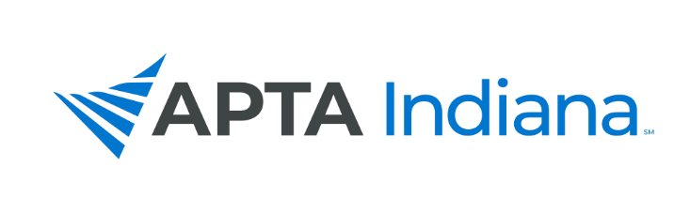

2019 ELECTION RESULTS

MEMBERSHIP SECRETARY

Chris Gales, PT, DPT, MS

TREASURER

Matt Zaudtke, PT, DPT, ATC
Board-Certified Clinical Specialist in Orthopaedic Physical Therapy

CHIEF DELEGATE

Blair Frye, PT

PTA CAUCUS REPRESENTATIVE

Rochelle Hawkins, PTA

DIRECTOR AT LARGE – NORTH

Bryan Bourcier, PT, DPT, ATC

DIRECTOR AT LARGE – SOUTH

Nate Nevin, PT, DPT
Fellow, American Academy of Orthopaedic Manual Physical Therapists

DELEGATE

Gail Altekruse, PT, MBA
Alicia Taylor, PT

ALTERNATE DELEGATE

Nate Nevin, PT, DPT
Fellow, American Academy of Orthopaedic Manual Physical Therapists

NOMINATING COMMITTEE

David Jackson, PTA

