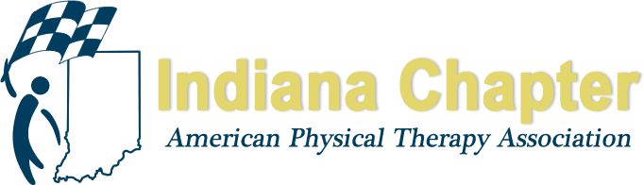

2019 SLATE OF CANDIDATES

MEMBERSHIP DIRECTOR

Chris Gales, PT, DPT, MS

TREASURER

Matt Zaudtke, PT, DPT, ATC
Board-Certified Clinical Specialist in Orthopaedic Physical Therapy

CHIEF DELEGATE

Blair Frye, PT

PTA CAUCUS REPRESENTATIVE

Rochelle Hawkins, PTA

DIRECTOR AT LARGE – NORTH

Bryan Bourcier, PT, DPT, ATC

DIRECTOR AT LARGE – SOUTH

Nate Nevin, PT, DPT
Fellow, American Academy of Orthopaedic Manual Physical Therapists

DELEGATE (2 TO BE ELECTED)

Gail Altekruse, PT, MBA
Nate Nevin, PT, DPT
Fellow, American Academy of Orthopaedic Manual Physical Therapists
Alicia Taylor, PT

NOMINATING COMMITTEE

David Jackson, PTA

