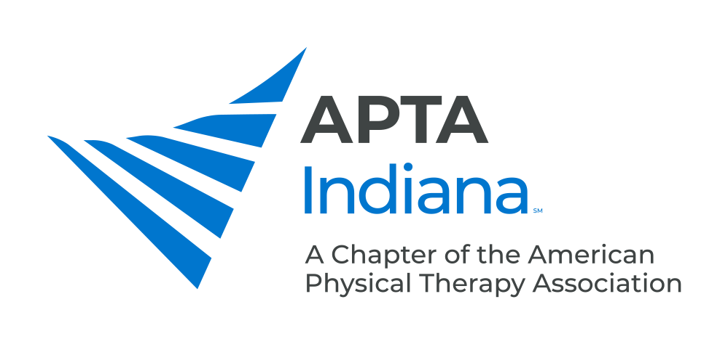

TEAM REHAB STUDENT PT SCHOLARSHIPS

These scholarships are intended to reward and encourage physical therapy (PT) students who are already demonstrating potential to be outstanding practicing clinicians. One scholarship will be awarded per program to a PT Student starting their third year at each Indiana school with a PT program.

Applications will be completed in the second year of the program. Recipients of these scholarships will each be awarded a stipend of $2,000 which will be distributed in one payment at the APTA Indiana Fall Conference Awards Banquet of the student’s final fall semester in physical therapy school.

APPLICATION PROCESS:

- Applicants will submit the following information electronically combined into one PDF file:

- Cover letter describing the applicant’s career objectives and highlighting what makes him/her a team player striving for excellence within the clinical environment.
- Resume
- Unofficial transcript for physical therapy school only, including GPA
- One letter of recommendation from a faculty member to be sent directly via email to the Awards & Scholarships Committee at inaptaawardscommittee@gmail.com
- One or more letters of recommendation from clinical instructors to be sent directly via email to the Awards & Scholarships Committee at inaptaawardscommittee@gmail.com

- At least two applicants must apply from a PT program for the scholarship to be awarded; one applicant or no applicants from an individual program will result in no scholarship being awarded in that program for that year.
- Direct questions and submit applications electronically to the Awards & Scholarships Committee at inaptaawardscommittee@gmail.com.

- Applications are due by April 30

SELECTION PROCESS

Scholarship recipients will be selected by the APTA Indiana Awards & Scholarships Committee and a representative from Team Rehab. The criteria the committee will utilize includes:

- Academic success (grade point average)
- Desire to excel and practice in the clinical environment (versus teach and/or research in the academic environment)
- Contribution to patient satisfaction/customer service during clinical education
- Ability to be a team player in the clinical environment (flexibility and helpfulness to the clinical staff during clinical education)
- Evidence of advancing practical knowledge of PT

