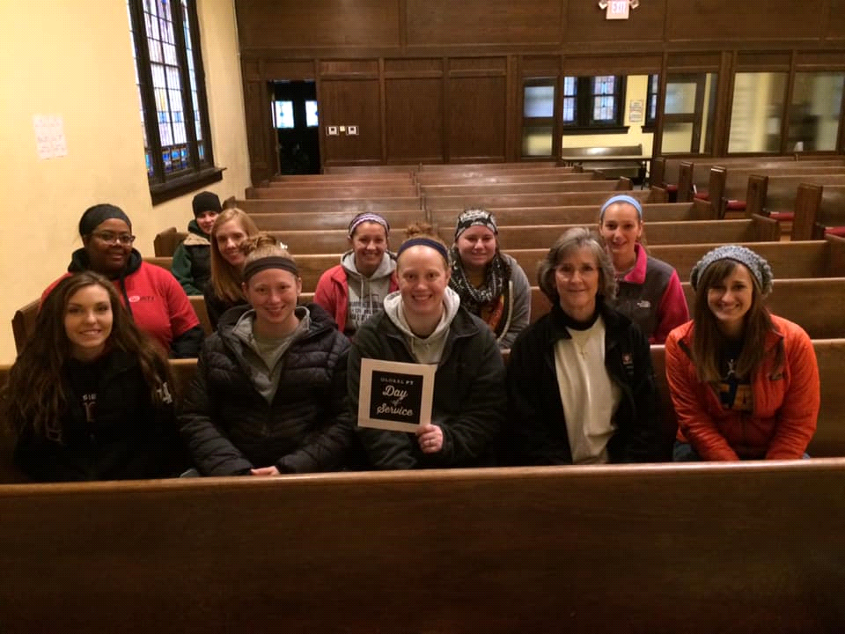  global  Pt Day of Service  10.12.19  JOIN us for Fall  clean up @  IU Student Outreach Clinic  Email Hannah Enochs to sign up:  henochs@indianapt.com | YOU are needed!  Join us for a PT Day of Service event during Physical Therapy Month  Sat Oct 13th  8-11am  Email to sign up  Give back to your community!  Neighborhood Fellowship Church  3102 E 10th Street  Indianapolis, IN 46201

