Going to Fall Conference this year?
Be a Part of the Global Physical Therapy Day of Service!

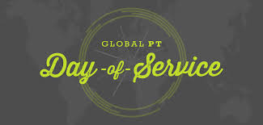

There will be a collection for the Fresh Start Recovery Center at the INAPTA Fall conference.

Items Needed:
Basic: Disposable razors, shaving cream, Non-aerosol deodorant, soap, shampoo, conditioner, combs, brushes, hair accessories, oral care products, lotion, feminine hygiene, baby and child hygiene
Babies and tots: formula (unopened) bottles, diapers, diaper wipes, training pants, baby powder & diaper rash paste, pacifiers, onesies, sleep sacks, boppy pillows, baby carriers, baby swings
Mothers: Bras, underwear, maternity clothing, business professional clothing, breast-feeding supplies
Family Friendly Activities: Books, toys (0-5yrs) activity & sensory mats, puzzles, board games, arts & crafts supplies, coloring books, DVDs

