Using the Biopsychosocial Model to Meet the Challenges of Persistent Pain:
A Discussion and Lab-Based Course

REGISTRATION FORM

Presentation Date: May 2-3, 2020

Day 1: Considering Pathoanatomical and Psychosocial Factors for Patients with Persistent Pain: A Discussion and Lab-Based Course (8 AM - 5 PM)

Day 2: Selecting Interventions for Patients with Persistent Pain: A Discussion and Lab-Based Course (8 AM – 3:15 PM)

***Day 1 and Day 2 can be taken together or separately. Day 1 is not a prerequisite for Day 2. Duplication of material will be avoided.

Location: Franciscan Health, 1201 Hadley Road
Mooresville, IN 46158
Speakers: Janet Delong PT, DPT, MSW, MHS
Steven Kinney PT, DPT, Board-Certified Clinical Specialist in Orthopaedic Physical Therapy
Registration Deadline: April 26, 2020
Contact Hours: Day 1: 7.5 Contact Hours Day 2: 6 Contact Hours

Registrant Information

Name: ____________________________________________________________________________________________________

Mailing Address: _____________________________________________________________________________________________

City: __________________________________________________ State: ___________ Zip: ______________

Phone #: ___________________________________________ Designation (PT/PTA/Student/Other): _______

E-mail: ____________________________________________________________________________________________________

Registration Fee All Proceeds are Going to the APTA Indiana PAC

One Day Only – Choose (□ Day 1 OR □ Day 2)

APTA Member $99
PT/PTA Non-Member $149
*The course material is not intended for use outside of any individual's license or regulations.
Furthermore, the use of the elements of physical therapist patient/client management (the Guide) as taught in this seminar is physical therapy only when performed by a physical therapist or by a physical therapist assistant under the direction and supervision of a physical therapist, in accordance with APTA policies, positions, guidelines, standards, and Code of Ethics.

PT/PTA Student $25

Both Days

APTA Member $179
PT/PTA Non-Member $229
PT/PTA Student $50

Payment

Check made payable to the APTA Indiana in the amount of $__________

TO PAY BY CREDIT CARD, REGISTER ONILNE HERE

Cancellation Policy: Registration less $25 if cancellation request received by April 26, 2020.

Mail registration to: APTA Indiana, 140B Purcellville Gateway Drive Suite 120, Purcellville, VA 20132
Questions? Call 317/505-1556, or e-mail info@inapta.org
Using the Biopsychosocial Model to Meet the Challenges of Persistent Pain:
A Discussion and Lab-Based Course

MAY 2-3, 2020

Franciscan Health, 1201 Hadley Road - Mooresville, IN 46158

SPEAKERS

Janet Delong PT, DPT, MSW, MHS
Steven Kinney PT, DPT, Board-Certified Clinical Specialist in Orthopaedic Physical Therapy

Day 1: Considering Pathoanatomical and Psychosocial Factors for Patients with Persistent Pain:
A Discussion and Lab-Based Course (8 AM - 5 PM)

Day 2: Selecting Interventions for Patients with Persistent Pain: A Discussion and Lab-Based Course (8 AM – 3:15 PM)

***Day 1 and Day 2 can be taken together or separately. Day 1 is not a prerequisite for Day 2. Duplication of material will be avoided.

COURSE DESCRIPTION

This discussion and lab-based course looks at the management of persistent pain from an evidence-based approach. A biopsychosocial model including pathoanatomical and psychosocial factors will be utilized. Interventions such as education, exercise, graded activity, and sensory discrimination training will be reviewed and performed. This course provides flexibility for the clinician’s busy schedule. The course can be taken as a one-day course on Saturday or Sunday, or as a two-day course. Saturday is not a prerequisite for Sunday, and duplication of material will be avoided.

DAY 1

Persistent pain is a widespread and often disabling condition, affecting many patients presenting for physical therapy services. While persistent pain is a challenging condition to treat, evidence-based strategies for treatment do exist.

Physical therapy management of persistent pain using a biopsychosocial model will be demonstrated. Psychosocial factors of persistent pain will be heavily analyzed. Though consideration of important pathoanatomical factors will be discussed. Participants will examine how words affect patients, highlight what words help healing, and identify words that harm. The neurophysiology of pain will be reviewed to enhance patient education. Participants will learn about motivational interviewing techniques. The course will also include strategies for sleep, mindfulness, and mental health referral.

Participants will learn and practice strategies to transition this knowledge into clinical practice. Discussion and lab will be utilized along with lecture learning formats.

COURSE OBJECTIVES

Upon completion of this course, participants will be able to:

- Identify relevant pathoanatomical considerations that change physical therapy management of persistent pain.
- Understand the impact that language has on patients.
- Develop communication strategies using healing words and avoiding harmful words.
- Develop language to use during patient education that is focused on enhancing self-efficacy and minimizing passive attitudes toward healing.
- Identify when referral to other healthcare professionals is appropriate.
- Explain the neurophysiology of pain to enhance patient education.
- Employ physical therapy interventions that address psychosocial influences of pain.
- Apply motivational interviewing concepts.
- Apply evidence-based concepts from the discipline of positive psychology.
- Explain physical therapy interventions as applied within a biopsychosocial model.

SCHEDULE

8:00-9:00 am Lecture and Discussion: Introduction, Pathoanatomical Model, Biopsychosocial Model
9:00-10:00 am Lecture and Lab: Focus on Bio- Discovering Concussions
10:00 – 10:15 BREAK
10:15-11:45 am Lecture and Discussion: Healing Language and Words that Harm
11:45 am 12:15 pm Lab: Integrating Healing Language into Clinical Practice
12:15-1:15 pm LUNCH (on your own)
1:15-2:15 pm Lecture and Discussion: Understanding Pain and Factors Affecting Pain
2:15-3:45 pm Lecture and Lab: Application of Psychosocial Concepts in Treatment
3:45-4:00 pm BREAK
4:00-5:00 pm Discussion: Case Studies

EACH REGISTRANT WILL RECEIVE A CERTIFICATE FOR 7.5 CONTACT HOURS

DAY 2

Physical therapy management of persistent pain can be difficult. Outcomes are often worse in this patient population. It can be challenging to select the most effective interventions. In many instances, traditional physical therapy interventions may have limited efficacy.

Participants will learn how pain classifications can be a valuable tool linking appropriate treatment to the patient. Participants will learn sensory discrimination training and graded motor imagery techniques. Other graded activity techniques will be discussed as well.

Participants will learn and practice strategies to transition this knowledge into clinical practice. Discussion and lab will be utilized along with lecture learning formats. A collaborative case study format will be used to tie concepts together at the end of the course.

COURSE OBJECTIVES

Upon completion of the course, participants should be able to:

- Discriminate between different pain classifications to best guide physical therapy management of persistent pain.
- Recognize the research on exercise, graded motor imagery, and sensory discrimination training.
- Perform sensory discrimination training techniques in an evidence-based manner.
- Perform graded motor imagery techniques in an evidence-based manner.
- Create graded exercise progressions that can be individualized for the patient.
- Categorize patients into appropriate pain classifications for sample case scenarios.
- Implement discussed interventions for sample case scenarios.

SCHEDULE

8:00-9:00 am Lecture and Discussion: Pain Mechanism Based Classification
9:00-10:00 am Lecture: Exercise and Physical Activity as Intervention for Persistent Pain
10:00-10:15 am BREAK
10:15 am-12:15 pm Lab: Graded Motor Imagery and Sensory Discrimination Testing
12:15-1:15 pm LUNCH (on your own)
1:15-2:15 pm Lecture and Lab: Graded Activity
2:15-3:15 pm Discussion and Lab: Case Studies

EACH REGISTRANT WILL RECEIVE A CERTIFICATE FOR 6 CONTACT HOURS

ABOUT THE SPEAKERS
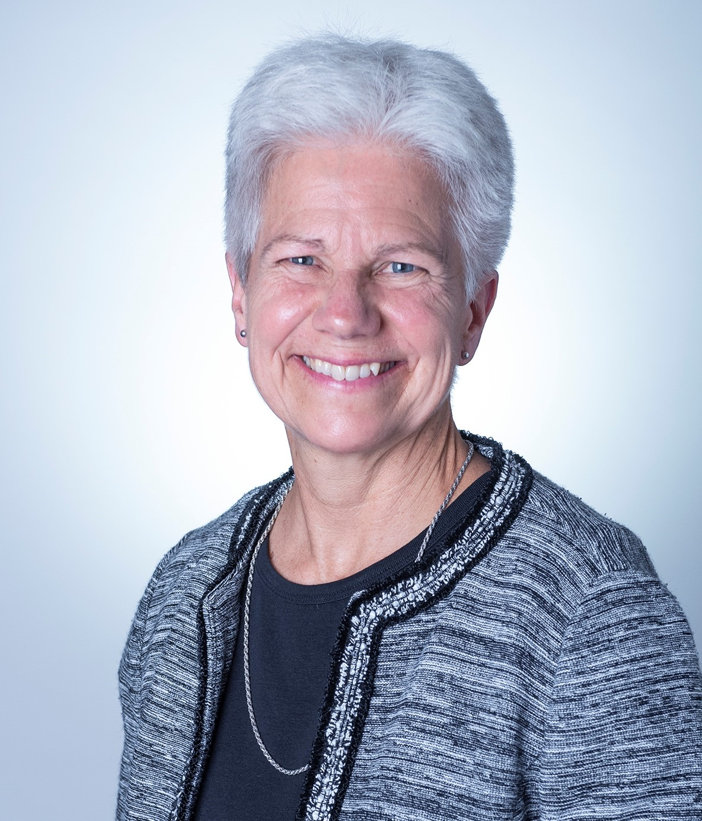
Janet Delong PT, DPT, MSW, MHS is a Doctor of Physical Therapy, a Licensed Social Worker and a Nationally Board-Certified Health and Wellness Coach. She is a Training Specialist and Research Associate for Prevention Insights at Indiana University, owner of Delong Wellness, LLC, and teaches Health and Wellness coaching for IU and Ivy Tech. Janet has a passion for working with persons who manage chronic pain, who have experienced trauma, who have issues around mental health and substance use and/or who are oppressed in some way. In addition to a diverse background in physical therapy patient and mental health client care, she provides education on Motivational Interviewing and other counseling/communication tools, chronic pain and wellness, and is interested in prevention on both an individual and a societal level. Janet is a member of the Motivational Interviewing Network of Trainers and the American Physical Therapy Association.

Steven Kinney, PT, DPT, Board-Certified Clinical Specialist Orthopaedic Physical Therapy, earned his Doctor of Physical Therapy degree from Columbia University in 2011. He is a Certified Strength and Conditioning Specialist (CSCS) and achieved certification as an Integrated Manual Therapist (CIMT) with Great Lakes Seminars. In addition, he completed extensive training in Neuro-Developmental Treatment, becoming certified under Recovering Function. He is a member of the American Physical Therapy Association and the American Academy of Orthopedic Manual Physical Therapists. He is a member of the American Physical Therapy Association’s Orthopaedic and Geriatric Sections. He is an orthopaedic certified specialist and currently pursuing a fellowship in orthopedic manual physical therapy at Regis University.
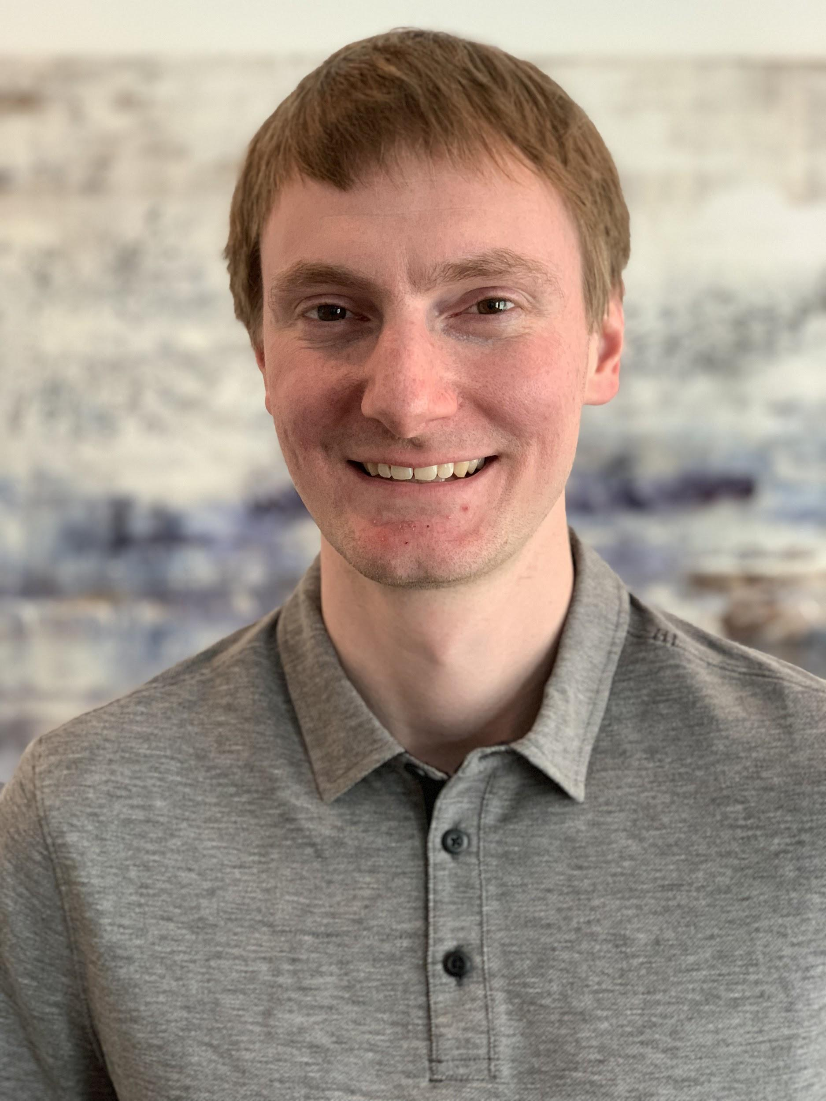

Steven Kinney has practiced in outpatient, subacute rehab, inpatient rehab, and acute care hospital settings with diverse patient populations. He is currently working at Indiana University Health in Bloomington, IN. He has been involved in the continuing education and training of physical therapists and other healthcare professionals. He has also volunteered as a physical therapist locally and abroad.

