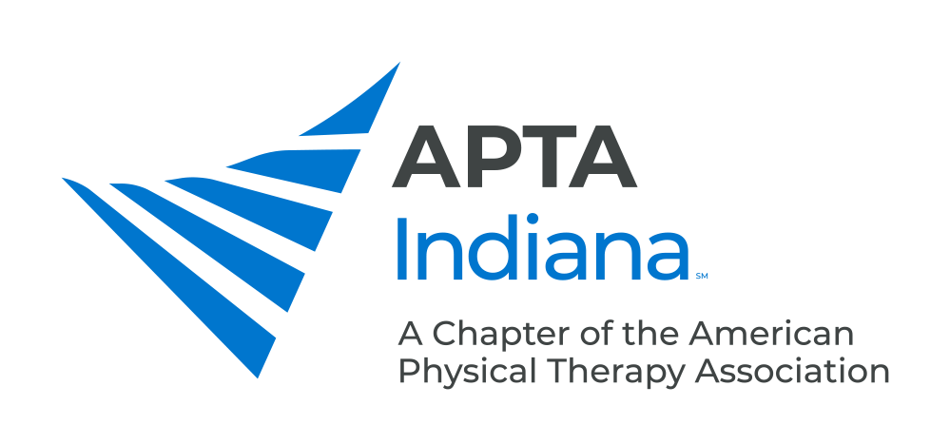

POSITION: Ethics Committee Member

BYLAW DUTIES: The Ethics Committee shall:

- Investigate and process ethical violations of Chapter members in a manner prescribed by the Association Board of Directors.
- Investigate reported legal violations and advise the state licensing body of infractions for appropriate action.
APPOINTMENT: The Chapter Ethics Committee consists of at least three (3) members who will be appointed by the Chapter President and approved by the Board of Directors. Each member shall serve a two (2) year term with one member being appointed in odd number years and two members being appointed in even number years. Members may serve beyond appointed terms at the discretion of the Board of Directors.

RESIGNATION: Letter of resignation shall be submitted to the Chapter Board of Directors.

DISMISSAL: May be dismissed by the Chapter Board of Directors for failure to attend meetings, failure to fulfill responsibilities and non-compliance with policies and procedures. Appeal of the dismissal must be submitted in writing to the Chapter Board of Directors.

ADDITIONAL RESPONSIBILITIES:

- Submit appropriate information to the Chapter Board of Directors/Committee Chair as it relates to ethical issue analysis for Chapter and Board members. (Consultation)
- Attend in person or contribute electronically to official business related to established Ethics violation investigations/hearings. (Disciplinary Process)
- Be knowledgeable regarding Disciplinary Procedural Process utilized in ethical violation investigation. (Disciplinary Process)
- Contribute to the investigation and processing of alleged ethical violations of Chapter members in a manner prescribed by the Association Board of Directors. (Disciplinary Process)
- Destroy duplicate reports at completion of investigations. (Disciplinary Process)
- Forward inquiries and membership recommendations to Committee Chair regarding ethical issues in the State. (External Education)
- Contribute input and review efforts of Committee updates to Ethics and Jurisprudence Course sponsored by the Chapter and to APTA regarding Code of Ethics revisions. (Internal Education)

BENEFITS: By contributing governance and visionary leadership, you help the Chapter move forward in accomplishing our mission. Business management skills would include ethical model-derived consultation/negotiation skills useful in practice.

TIME COMMITMENT: This would include quarterly review of ethical questions brought to committee's attention for full Board report by the Chair; a time commitment related to formal review of an ethics complaint could be substantial as the Committee process an investigation, interviewing and hearing implementation are formal and time-based, as spelled out in Disciplinary Procedural Documents established by APTA. Informal Committee meetings may take place during State Conference.

QUALIFICATIONS: Must be an APTA Indiana PT, Life PT, PTA or Life PTA Member in good standing. In order to be successful, a basic knowledge of computers is required for reporting and email purposes. There are a number of online educational resources on the APTA Learning Center that provides ethical processing information and skills as well as those found on the established Resource Center.

EVALUATION: The Chapter President/Ethics Committee Chair will contact you prior to the end of your term for feedback on your experience as a volunteer leader. This will be used to update job descriptions and orient future Chapter leaders.

ETHICS COMM MEMBER: 07/15/89
Rev: 12/03/96; 01/12/09; 05/23/16; 10/11/19

