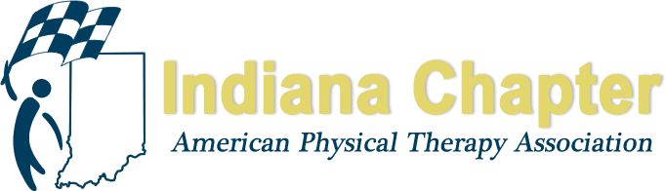
2019 INAPTA FALL CONFERENCE

OCTOBER 11-12, 2019

FRIDAY, OCTOBER 11, 2019

UNIVERSITY OF INDIANAPOLIS
SCHWITZER STUDENT CENTER
Indianapolis, IN

MEET THE CANDIDATES RECEPTION (5-5:30 pm)

BUSINESS MEETING (5:30-7pm)

AWARDS DINNER AND CEREMONY (7-9 pm)

SATURDAY, OCTOBER 12, 2019

UNIVERSITY OF INDIANAPOLIS
HEALTH PAVILION
INDIANAPOLIS, IN

SESSION 1 - I just want to implement something” - Systematic implementation of high intensity stepping training in inpatient neurologic rehabilitation

Speakers: Abbey Plawecki, PT, Chris Henderson, PT, PhD, Board-Certified Clinical Specialist in Neurologic Physical Therapy, Maghan Bretz, PT, Board-Certified Clinical Specialist in Neurologic Physical Therapy, T. George Hornby, PT, PhD

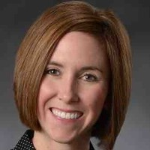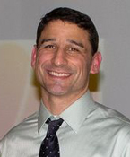

Course Description

Emerging research suggests provision of substantial stepping practice at high cardiovascular intensities can improve walking and non-walking independence in patients with neurological injury. However, clinical implementation of these interventions early post-injury is limited. This proposed course will outline the rationale, decision-making processes, and potential barriers and facilitators related to delivery of high intensity training (HIT) early following neurological injury to empower clinicians to successfully implement HIT in inpatient rehabilitation.

Current clinical practice suggests clinicians provide interventions directed towards the multiple impairments that contribute to decreased mobility and independence, and at cardiovascular intensities that rarely reach aerobic thresholds. Conversely, available data reveal significant correlations between the amounts and intensities of stepping practice to mobility outcomes. However, implementation of HIT stepping training in inpatient rehabilitation can be difficult. Specific barriers include the severity of motor and cognitive deficits as well as medical complications, which limit the capability to perform basic functional mobility tasks. Implementation can also be challenging given the clinical demands and available resources during inpatient rehabilitation. This course will provide the rationale for implementation of HIT early post-injury, selected implementation strategies, and case examples to identify and overcome potential barriers encountered in inpatient rehabilitation.

Course Objectives

After completing this course, the participant will be able to:

- Demonstrate understanding of evidence supporting high intensity training techniques and parameters.
- Identify and apply strategies to implement high intensity training in inpatient rehab.
- Understand barriers to implementation and strategies to address them.
- Incorporate feedback from outcome measures and heart rate data to guide clinical decision making.
- Accurately document high intensity training sessions within for inpatient rehabilitation.

Speaker Information

Abbey Plawecki, PT is senior physical therapist at the Rehabilitation Hospital of Indiana specializing in the rehabilitation of individuals following stroke and brain injury. She also works as a research physical therapist within Indiana University’s Locomotor Recovery Lab. She recently presented a case series at APTA’s Combined Sections Meeting on the topic of high intensity gait training during inpatient rehabilitation following neurologic injury.

Chris Henderson, PT, PhD, Board-Certified Clinical Specialist in Neurologic Physical Therapy is an Assistant Research Faculty within the School of Medicine at Indiana University and physical therapist at the Rehabilitation Hospital of Indiana. Dr. Henderson holds a PhD in Movement Sciences, with previous experience in mechanical engineering. Dr. Henderson’s work is focused on optimizing the rehabilitation of individuals following acute onset neurologic injuries and translating evidence-based interventions into routine neurologic physical therapy practice. Dr. Henderson has co-authored publications on the topic of stroke rehabilitation and presented on the topic at both regional and national conferences. Most recently, Dr. Henderson presented at the 2019 Combined Sections Meeting and was awarded Best Platform Presentation by the Stroke Special Interest Group.

Maghan Bretz, PT, MPT, Board-Certified Clinical Specialist in Neurologic Physical Therapy is an outpatient clinician, Site Coordinator of Clinical Education and Director of the St. Vincent Evansville & University of Evansville Neurologic Residency Program in Evansville, Indiana. She serves as an adjunct faculty member in the Doctoral Physical Therapy Program at the University of Evansville, delivering content in the neurologic rehabilitation curriculum. She also serves as a committee member on the Locomotor Training Clinical Practice Guideline Knowledge Translation (KT) Task Force, charged with dissemination and implementation of current evidence on walking recovery in the chronic ambulatory stroke, brain injury and motor incomplete spinal cord injury populations. Over the past six years, Maghan has been successful in implementing high intensity locomotor training using various Knowledge Translation strategies at her local hospital organization​

T. George Hornby PT, PhD is a Professor of Physical Medicine and Rehabilitation at Indiana University and the Director of the Locomotor Recovery Laboratory at the Rehabilitation Hospital of Indiana. Dr. Hornby’s work is focused on optimizing rehabilitation interventions to improve lower extremity function in patients with stroke and spinal cord injury, with a primary focus on restoration of walking ability. By integrating both quantitative and clinical measures of motor function, Dr. Hornby’s work aims to understand the biomechanical and physiological impairments underlying limitations in locomotor activity in these populations, and the relative efficacy and mechanistic basis of specific interventions to enhance function. Recently, his activity has focused on direct translation of his research to clinical practice in rehabilitation. Dr. Hornby has co-authored over 90 research publications in scientific journals. He is PI or Co-PI on active R01, DOD, and NIDRR center grants, with both national and international collaborations. He is also the Director of Research for the Academy of Neurologic Physical Therapy.

Recommended Participant Level: Intermediate

SESSION 2 – TRAUMA, ABUSE, PAIN AND DYSFUNCTION: THE ROLE OF PHYSICAL THERAPY

Speaker: Beth Genday PT, MHS

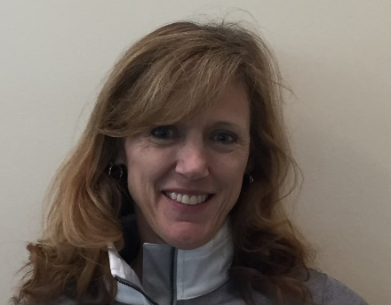

Course Description

An overview of the evidence linking pain (chronic, pelvic and other) to trauma and abuse and strategies for the physical therapist. Alternative strategies for discussing mindfulness and current chronic pain strategies and the evolution of a team approach for these individuals.

Course Objectives

After completing this course, the participant will be able to:

- Review of current evidence linking chronic pain to trauma and abuse.
- Mastering when and how to discuss trauma and abuse, especially sexual and the role of the Physical therapist.
- Gain a deeper understanding of how trauma and abuse extend beyond issues with the pelvis and how the therapist can begin to identify individuals who may have this as a factor affecting their pain and dysfunction.
- Identifying strategies beyond “exercise and relaxation” and appropriate language to educate patients about the anatomy of trauma and abuse and pain.

Speaker Information

Beth Genday has been a practicing PT for over 30 years with populations in 6 states and 2 countries. She has worked with patients having neurologic issues, amputations, acute care stays, inpatient rehab stays, chronic pain, outpatient orthopedics issues, manual therapy needs, developmental pediatrics and a foray into academia teaching at Penn State and several PTA programs in South Carolina. Since the beginning of her practice, she has been the recipient of first disclosure of abuse and trauma and felt ill equipped on what to do and the role this played in pain. Thus, she has pursued study of the relationships of the body’s anatomy and the sympathetic and parasympathetic nervous systems and mind body connection and does work with suicide prevention. Beth feels in today’s world of opioid addiction and chronic pain management, the effect of abuse and trauma is an area that needs more focused attention for all genders, ages and dysfunction.

Participant Level: Appropriate for all levels of practice, not just pelvic PTs. Orthopedic physical therapists and chronic pain specialists would highly benefit.

SESSION 3 – What I Wish I Would Have Known: A Financial Primer for the (Fresh) Clinician

Speaker: Will Butler, DPT, Licensed Financial Advisor

Course Description

Financial Literacy is as important to life as movement. And similar to movement, it’s misunderstood and intimidating to many. This presentation is designed to create a purposeful and open dialog surrounding finances; it centers on my reverse engineered experience as a fresh clinician through my current lens of a licensed financial advisor.
Course Objectives

Participants will learn:

- How to raise awareness around fact and fiction regarding student loans, including Income Based Repayment, Public Service Loan Forgiveness, Consolidation vs Refinancing;
- How to audit employer benefits;
- Negotiating Strategies;
- Goal Driven Budgeting;

Speaker Information

Will Butler is a physio by training and practices financial planning by choice. He is motivated by human potential & past misfortune. His mission is to change healthcare by improving the life of the clinician through education and application financial planning. He received his DPT from the University of St. Augustine. He enjoys few things more than Ben & Jerry’s ice cream, helping clinicians is one of those things. He values humor, knowledge, and building lasting relationships. His presentation, “What I Wish I Would Have Known…”, is the result of a critical review of his transition from student to clinician which turned into a wish list of knowledge that would have made his personal and professional life easier. The topics that will be covered include: student loans, employer benefits, contract negotiations, basic money management, and goal setting. The most common responses to Will’s presentation, “Why has no one told us these things?!” and “Thank you, I’ve searched for hours and days for the things you answered in minutes.” Those who attend will leave with greater sense of mission and vision.
Participant Level: SPTs, SPTAs, Early Career Clinicians

SESSION 4 – ETHICS AND INDIANA JURISPRUDENCE
Speakers: Pauline Flesch, PT, MPS and Carol Krueger-Brophy, PT

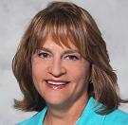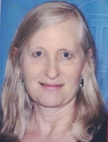

Course Description
This course on Indiana Physical Therapy Ethics and Jurisprudence is designed to provide a review of the ethical and legal standards that provide a basis for professional practice in Indiana. The newly revised Indiana Practice Act including the new provisions related to direct access and scope of practice is reviewed. A description of the concepts of non-maleficence, beneficence, autonomy, fidelity, veracity and justice in medical ethics are discussed and the individual and cultural differences that influence ethical practice are described. APTA core values, Guide for Professional Conduct, APTA Code of Ethics for the Physical Therapist and Standards of Ethical Conduct for the Physical Therapist Assistant serve as resources for this presentation. Clinical scenarios are used to assist clinicians in applying the resource documents to determine appropriate ethical behavior and provide an opportunity for self-reflection.
Course Objectives
After completing this course, the participant will be able to:
- Define the medical ethics concepts of non-maleficence, beneficence, autonomy, veracity, fidelity, and justice.
- Apply the current APTA Code of Ethics for the Physical Therapist, Standards of Ethical Conduct for the Physical Therapist Assistant, and APTA Guide for Professional Conduct in clinical scenarios to achieve ethical outcomes.
- Differentiate between legal and ethical principles in analyzing ethical dilemmas and/or case scenarios.
- Access current resource documents on the APTA website related to ethical practice of physical therapy.
- Understand the 2019 changes to the Indiana Physical Therapy practice act and how the new law impacts practice in Indiana.
Speaker Information
Pauline Flesch recently retired from Indiana University Health in Indianapolis, Indiana where she practiced for 33 years. While there she served in a variety of leadership roles; most recently as the Executive Director of Rehabilitation and Fitness Services. Pauline graduated with a BS in physical therapy from The Ohio State University and received her Masters of Management in Public Service from DePaul University in Chicago, Illinois. She has been very active in the American Physical Therapy Association (APTA) at both the state and national level. Pauline served on the APTA Board of Directors 2001-2007, as an Indiana delegate to the House of Delegates, as a member of the APTA Vision Task Force and was past chairperson for the Federal Government Affairs Committee and past Indiana Chapter president. She has served as Legislative Chairperson for the Indiana Chapter since 1998 when she started working on the journey to achieve direct access which was passed in 2013. Pauline continues to support and advocate for physical therapy in her new role as the Executive Director for the North Carolina Physical Therapy Association.
Carol Krueger-Brophy has been a practicing physical therapist for over 35 years, treating patients with neurological disorders, with a particular concentration in geriatrics and vestibular disorders. She works as an outpatient therapist at Franciscan Health in Lafayette, IN. Carol has a BS in PT from Oakland University and a JD from the University of Michigan School of law; she is an adjunct faculty member at the Loyola Chicago Beazley Institute for Health Law and Policy. She has a particular interest in the intersection of law, medicine and ethics. Carol taught Ethics to physical therapy students at Belmont University for 17 years and has taught courses in ethics and jurisprudence to practicing and student physical therapists. She has served on hospital and state chapter Ethics committees and is presently a member of the INAPTA Ethics Committee. Recent academic work explores the use of high-fidelity mannequins and standardized patients to instruct interdisciplinary teams in managing ethics scenarios in realistic clinical environments.

SESSION 4 – Signaling expertise and empathy through metaphors: Using language that heals

Speakers: Steven Kinney PT, DPT, Orthopaedic Manual Therapy Fellow in Training, Certified Integrated Manual Therapist, Certified Strength and Conditioning Specialist, Runyon Problem Solving Framework Certification in NeuroDevelopmental Treatment and John Kiesel PT, DPT, Board-Certified Clinical Specialist in Orthopaedic Physical Therapy, Certified Therapeutic Pain Specialist (TPS), Certified Strength & Conditioning Specialist (CSCS)

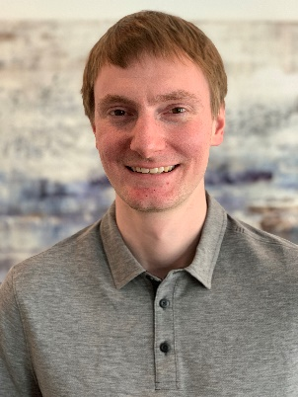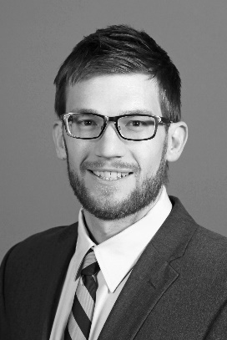

Course Description

An often-overlooked element of physical therapy practice is how we communicate. The words used to inform patients about their condition are powerful and can impact thoughts, emotions, and ultimately the actions of these individuals. Evidence continues to grow in support of the importance of psychological factors and coping mechanisms as predictors of disability and pain. As practitioners, we must evolve in our approaches to patient communication and education to optimize outcomes. Just like manual techniques and exercises, precision and skill matter.

Pain is a condition that can promote worry, and even one off-hand comment from a healthcare provider can have a major influence on a patient’s expectations of recovery. Patients are far more likely to hold on to language and phrases that imply danger. Learning how to be strategic with your language and metaphors can improve your patient’s quality of life and self-efficacy.

In this session, participants will examine how words affect patients, highlight what words help healing, and identify words that harm. Participants will learn and practice strategies to transition this knowledge into clinical practice.

Course Objectives

After completing this course, the participant will be able to:

- Explain how the words we use affect our patients.
- Differentiate between harmful and healing words as applied within a biopsychosocial model.
- Develop language to use during patient education that is focused on enhancing self-efficacy and minimizing passive attitudes toward healing.
- Implement communication strategies that promote adaptive coping for sample case scenarios across different settings.

Speaker Information

Steve Kinney has practiced in outpatient, subacute rehab, inpatient rehab, and acute care hospital settings with diverse patient populations. He currently is working at Indiana University Health in Bloomington, IN. He has been involved in the continuing education and training of physical therapists and other healthcare professionals. He has volunteered as a physical therapist locally and abroad.

John Kiesel works as an assistant professor at Indiana State University in the Doctor of Physical Therapy program. He maintains a clinical practice as a physical therapist in an outpatient orthopedic setting treating a mix of chronic pain and athletes with a focus on spine care. His research focus is on active interventions and education to better treat people in pain. He has a particular passion for translating the current evidence on our understanding of pain and helping others use this to optimize how they move and live.

Participant Level: Intermediate

LAMP Leadership 201: Advanced Leadership Development The Catalyst for Leading Others

Speakers: Dan Dziadura PT, DHSc, MSPT and Kerry Wood, PT, DPT

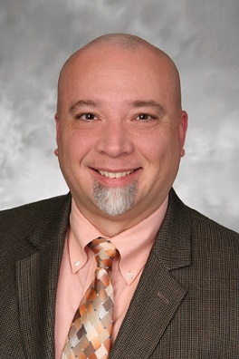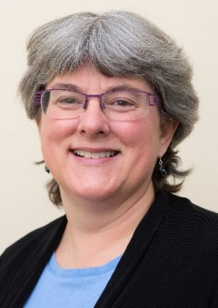

Course Description

Leadership doesn’t require a title. You can lead up, down and across your team. This program is for anyone interested in understanding himself or herself so that they can then develop skills to lead others. Whether you are a student, early professional or seasoned/formal leader, this certificate program offers “a-ha” moments of personal and professional growth. This program is designed for anyone in the healthcare field. We have provided training to PT, PTA, OT, COTA, SLP, Physicians, Nurses, Human Resources, Coders, educators and others in the field.

With rapid changes in the dynamics of the healthcare work environment, leadership is now more important than ever before. In order to be a successful leader, you must be your own first follower. By understanding your core values, personal mission and vision, you can ensure that you are leading others with authenticity. Learning your default communication and conflict resolution styles, you can then understand how to meet others where they are. Once you understand yourself, you can then seek to understand others and how to lead them.

HPA the Catalyst offers the LAMP Institute of Leadership Certificate in Healthcare Leadership, which focuses on personal and professional growth is earned once you’ve completed the following elements of the program. In each dynamic program there will be self-assessment tools utilized. While there is didactic material, the learning style is primarily experiential. Through lively discussion and activities, you will apply what you are learning.

Course Objectives

After completing this course, the participant will be able to:

- Identify and discuss personal characteristics of adaptive and transformational leaders.
- Determine how to promote a shared vision that others will follow.
- Recognize the importance of establishing relational and organizational trust.
- Generate strategies to lead highly effective teams and foster followership.
- Formulate a plan to lead others through change.
- Develop effective negotiation strategies.

Speaker Information

Dan Dziadura PT, DHSc, MSPT is responsible for developing and implementing strategies for assigned service line(s) including clinical care, diagnostic evaluation, and non-clinical functions. Provides leadership, direction and support for clinical services in the pursuit of quality outcomes & reduced costs. Shapes and interprets the standards required to ensure a high degree of patient, physician, and employee satisfaction.

Kerry Wood is currently serving as a per diem physical therapist in the Acute Care and Inpatient Rehabilitation settings at University of Vermont Medical Center; an Academic Medical and Level I Trauma Center located in Burlington, VT.
Kerry spent more than 25 years in management for the Acute Inpatient Rehabilitation Center of the University of Vermont Medical Center, and serving as an adjunct professor at Simmons College and the University of Vermont; Rehabilitation and Movement Sciences. She served as a Vital Smarts Crucial Conversations Faculty for ten years. Kerry has been involved with HPA The Catalyst and APTA in various capacities, including Vice President of HPA, serving on various task forces, LAMP faculty member, committee member and board member. She currently serves as a PT PAC Trustee with APTA.
Kerry loves patient care, sharing this life journey with her best friend and husband, Richard Wood, time with family and friends, and being “Mimi” to her grandchildren. Kerry’s passion for global health and social responsibility are fueled by learning and sharing of her Native American Abenaki heritage and she spends her free time making traditional Abenaki Baskets. Kerry serves as Co-Chair for Alnôbaiwi Council (In the Abenaki Way), a council dedicated to learning and teaching the Abenaki Native American Culture for the Abenaki and greater communities.
Must have completed Lamp 101 to take Lamp 201.

