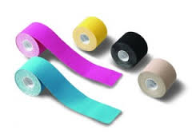
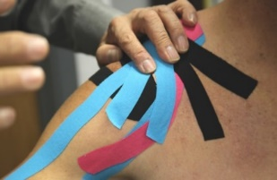
Kinesiology Taping Course

Saturday, March 2, 2019
8:00 a.m. – 4:30 p.m.
Franciscan Health, 8111 S. Emerson, Indianapolis, IN 46237

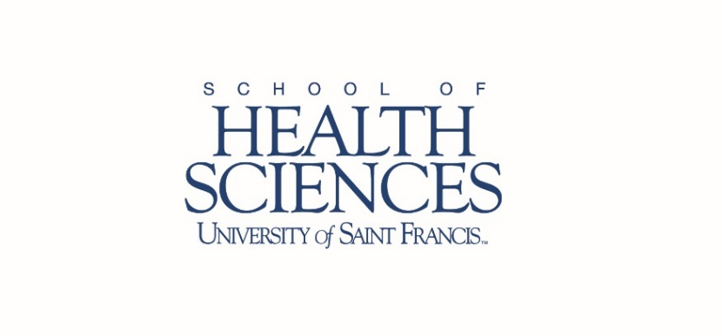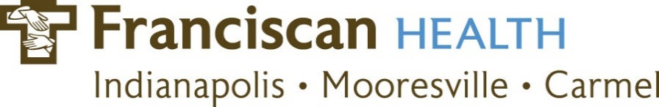
COURSE DESCRIPTION: For several decades, therapeutic taping has been used to improve patient function, correct postural imbalances, reduce pain, and prevent injury. While kinesiology taping is widely used in athletics, it has yet to reach its full potential in more traditional rehabilitation settings. Use of kinesiology tape layered with function-based therapy intervention may improve functional outcomes.

This hands-on course is designed to guide participants through appropriate therapeutic taping applications for this expanding target population. Participants will focus on the fundamentals and techniques of taping as well as specific applications appropriate for populations of neurologically and orthopedically impaired patients including applications for pain, edema, shoulder subluxation, posture and positioning, and more.

This course will provide participants with taping techniques which can immediately be integrated into practice. Participants will learn non-invasive, practical methods of managing conditions specific to these populations. Taping techniques learned can be used in virtually any environment and with few contraindications.

Participants will earn 7.0 contact hours. Upon completion of the course, certificates of attendance will be provided to all participants. The 7.0 contact hours qualify for continuing competence requirements for Indiana PTs, PTAs, OTRs, and COTAs.

AUDIENCE: PTs, PTAs, OTRs, COTAs, and ATCs. Five student spots also available.

INSTRUCTOR: Angela Reimer, OTD, MOT, OTR, CBIST received both her Bachelor of Science in Health Sciences and Master of Occupational Therapy, from The University of Findlay and her Doctorate from Indiana University-Purdue University – Indianapolis. She has over 18 years of clinical experience with geriatric and neurologically impaired populations, including serving as a regional manager and educator for several rehabilitation organizations. Additionally, Ms. Reimer is a member of the American Society for Neurorehabilitation, the American Congress of Rehabilitation Medicine, the Indiana Occupational Therapy Association, and The American Occupational Therapy Association, and is a member of several regional and national practice committees such as the AOTA's national credentialing committee. Ms. Reimer has presented courses across North America on kinesiology taping and stroke rehabilitation, including several "standing room only" courses for stroke practitioners at the AOTA conference, and has lectured extensively for PT and OT programs across the Midwestern United States. Ms. Reimer is co-director and speaker for Certified Stroke Rehabilitation Specialist workshops, the field's only stroke certification for physical and occupational therapists. Her unique combination of education, experience and passion translates into highly innovative and effective rehabilitation solutions.

COURSE OBJECTIVES: Upon completion of this course, the participant will be able to:
- Describe fundamental kinesiology tape application principles.
- Discuss primary benefits and limitations of taping techniques.
- Identify contraindications and precautions for use of taping.
- Compare and contrast common therapeutic taping techniques and the indications for each.
- Demonstrate correct application of fundamental taping techniques.
- Apply various taping techniques for treatment of clinical conditions using concepts gained in this course.
COURSE FEE: Course fee includes continental breakfast, snacks and kinesiology tape for the lab work.  $225 per individual  $200 for USF PTA Clinical Instructors*  $50 for PT, PTA, OTA or ATC students (five spots available) additional students will be placed on wait list  *USF PTA Clinical Instructor is defined as the PT or PTA responsible for the clinical experiences of a USF PTA student. This is verified by the Clinical Instructor’s signature on the USF Clinical Education Assessment Form or on the USF PTA CPI Instrument.  Registration Deadline: Monday, February 25, 2019  For questions or concerns, please contact  Mary Kay Solon at mksolon@sf.edu | Course Schedule: Contact hours: 7.0  7:45 - 8:00 a.m. -Registration  8:00 - 10:00 -Intro to taping application and theory  10:00 - 10:15 -Break  10:15 - 12:00 -Postural taping lab  12:00 - 1:00 p.m. -Lunch on own (cafeteria or nearby)  1:00 - 2:30 -Upper extremity taping lab  2:30 - 2:45 -Break  2:45 – 4:15 -Lower extremity taping lab  4:15 - 4:30 -Wrap up and course evaluation

For Registration go to: https://www.eventbrite.com/e/kinesiology-taping-course-2019-registration-53909923031

