Applying Exercise Prescription Principles
across the Health Care Continuum for the Older Adult
with Multiple Chronic Conditions
Saturday, November 10, 2018
7:30 a.m. – 4:30 p.m. Doermer 156 A & B
USF PTA Program 2701 Spring Street Fort Wayne, IN 46808

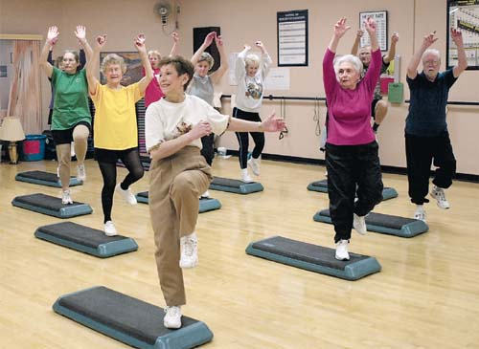
COURSE DESCRIPTION: This course will provide information on outcome measures and exercise for people with multiple chronic conditions. Chronic diseases and conditions such as heart disease, stroke, cancer, diabetes, obesity, frailty, and arthritis are among the most common, costly, and preventable of all health problems. This course will review the anatomical and physiological changes that occur with aging, including disease and disability, and the effects of inactivity on these changes. The best tests and measures for the examination of aging adults will be detailed, and participants will perform the tests and measures throughout the course. Barriers to effective exercise prescription and motivational strategies for overcoming barriers will be discussed. Participants will have the opportunity to perform all of the balance and gait measures and be tested in a lab practical. Discussion of documentation, teaching hints, and reimbursement will facilitate participants’ ability to provide programs in the home health clinical setting.

Participants will earn 7.0 contact hours. Upon completion of the course, certificates of attendance will be provided to all participants. The 7.0 contact hours qualify for Category I continuing competence requirements for Indiana PTs, and PTAs.

AUDIENCE: Physical Therapists and Physical Therapist Assistants Course capacity: 50

INSTRUCTOR: WILLIAM H. STAPLES PT, DPT, DHSc: Dr. Staples is a Board-Certified Clinical Specialist in Geriatric Physical Therapy (GCS) and Certified Exercise Expert for Aging Adults (CEEAA). He is an Associate Professor with tenue for the entry-level DPT Program at the Krannert School of Physical Therapy, University of Indianapolis. Bill is author of Geriatric Physical Therapy: A Case Study Approach, published by McGraw-Hill, 2016, and former two-term president of the APTA Academy of Geriatric Physical Therapy (formerly Section on Geriatrics).

COURSE OBJECTIVES: Upon completion of this course, the participant will be able to:
- Describe chronic disease processes found in older adults
- Discuss current evidence based theories of exercise for older adults including strength, power, and endurance.
- Summarize five functional outcome measures that are appropriate to use for older adults with multiple chronic conditions.
- Formulate a comprehensive exercise program to address aerobic, strength, gait, and balance impairments associated with the most prevalent chronic conditions in older adults.
- Understand geriatric syndromes including frailty.
- Identify and implement exercise for geriatric syndromes and frailty.
- Critique case examples of exercise programs commonly used across the continuum of care to determine if they meet the exercise principles needed to effect positive change.
COURSE FEE: Course fee includes continental breakfast and course handouts.  $125 for PTs and PTAs  $100 for USF PTA Clinical Instructors  $25 for PT or PTA students (limit 5; additional students will be placed on waitlist)  *USF PTA Clinical Instructor is defined as the PT or PTA responsible for the clinical experiences of a USF PTA student. This is verified by the Clinical Instructor’s signature on the USF Clinical Education I or II Assessment Form or on the CPI form for Clinical Education III or IV.  Registration Deadline: Friday, November 2, 2018 | Course Schedule: Contact hours: 7.0  7:30 - 8:00 a.m. -Registration - light breakfast  8:00 - 10:00 -Lecture, Videos, Functional Screening Tools  10:00 - 10:15 -Break  10:15 - 12:00 -Lecture, Videos  12:00 – 1:00 -Lunch On Your Own  1:00 - 2:30 -Lab  2:30 - 2:45 -Break  2:45 - 4:00 p.m. -Lecture, Discussion, Intervention Skills, Case Studies  4:00-4:30 -Questions, Post-Test  For Questions or concerns, please contact Beth Shutt at bshutt@sf.edu.
For Registration go to: https://www.eventbrite.com/e/applying-exercise-prescription-principles-for-older-adults-registration-47951645663

