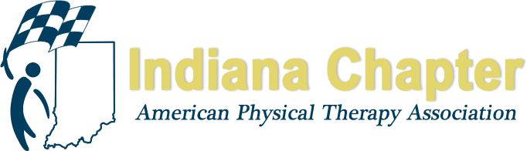

INAPTA ANNUAL REPORT

Southern Region Director at Large

Nathan Nevin, PT, DPT, MTC, FAAOMPT

HIGHLIGHTS FROM 2018
March 3, 2018-1st SE District Meeting along with Pain Course with Instructor Chad Garvey @ Ivy Tech Sellersburg
February 21 – SW District first meeting of the year. The speaker was Dawn Mabrey, PT, DPT, PCS who presented "Developmental Coordination Disorder DCD, Recognizing its Many Faces."
April – SW District held a membership event at the Bowling Alley
May, 9, 2018-2nd SE District Meeting with Ivy Tech PTA student Poster Presentations @ Ivy Tech Sellersburg
June 21 – participated with PT Night Out with Kentucky's Central District at Parlor in Jeffersonville, IN
August 15, 2018-3rd SE District Meeting with Bryan Swint from Kenney Orthopedics presenting on Orthotics &Prosthetics at Southern Indiana Rehab Hospital
Director at Large worked with Ryan Wood and Brad Shupe to help organize the PAC golf scramble. Unable to play due to being out of town but assisted in ways to raise more money during the scramble. Helped with advertising.
September 5, 2018-Annual PAC Fundraiser-Wine Tasting @ River City Winery in New Albany, IN-will report final numbers once obtained
PT Day at the Statehouse - Organized a bus meeting at Ivy Tech taking students, faculty, PTs, and PTAs from across the SE district and even students from Bellarmine University to the PT Day at the Statehouse. Although there were some issues with the bus, everything worked out getting home, although a little late, those people were able to get a tour with Rep Ed Clere around the statehouse.
Participated in a phone call early in the spring with Emily Slaven and other directors at large – discussed ways to improve communication between districts, improve attendance and participation at district level, and ways to create more consistency and uniformity with districts including bylaws, district meetings, communication, district boards.
Organized a meeting on 3/24 during the INAPTA Spring Meeting with district chairs and at least one representative from each district and directors at large to focus on making district bylaws more consistent, how each district can more consistently follow bylaws during their meetings, creating template and schedule for emails to Suzie in regards to advertising for events/meetings, the use of money for food/snacks/drinks during meetings, fundraising ideas for each district, PAC fundraising ideas for each district, and last identifying 2-3 people who may be “key contacts” in regards to disseminating information over the next year with legislative information and/or needs.
Created PT Day of Service Committee in the SE District – Nate Nevin, Sarah Merlano, Jessica Long-Hricak. Began communication with Hannah Enochs. We have found two organizations to work with for the October 13 PT DOS – Lifespan Resources and Keep Louisville Warm.

PROJECTIONS FOR REMAINDER OF 2018 AND 2019
October 13, 2018- PT Day of Service: Morning and Afternoon opportunities:

* Saturday Morning Volunteering – Work with Lifespan Resources to assist an elderly disabled member of the community with house and yard clean up.

*Saturday Afternoon Volunteering – Work with Keep Louisville Warm helping prepare and handout meals to those people in need in our community.
October 24, 2018-4th and final SE District Meeting with Laura Bray-Prescott presenting on the knee and Emily Slaven presenting on proposed changes of Indiana Physical Therapy Practice Act @Ivy Tech
March 2, 2019-Tentative date for annual SE District sponsored CEU Course; Topic is on the shoulder; Goal is to have an orthopedic surgeon present as well as 2-4 PTs from across the SE district present.
SW District hopes to finalize ballot for online elections
Director at Large goals are to attend the Fall Conference and SE district fall meeting; Have a meeting with Sean Bagbey to continue discussions in regards to making district bylaws more consistent; Continue with discussions with Gail and Ryan to continue to improve things at the district level; Assist in organizing CEU course for March 2019 with SE district; Assist SW district in getting a chairperson and finalizing elections; Assist new chairperson in their role and help with any future meetings, events for 2019. Participate in PT Day of Service with Lifespan Resources and Keep Louisville Warm.

