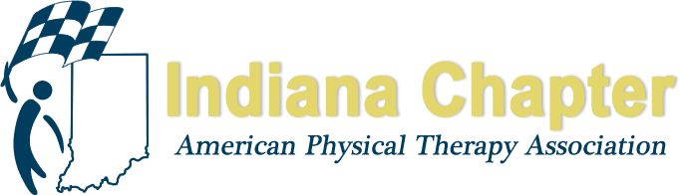

INAPTA ANNUAL REPORT

PR Committee

Kevin Sanborn PT, DPT, OCS

HIGHLIGHTS FROM 2017
1. Helped to plan and host PT Day at the Statehouse
2. Improved social media presence through consistent posting on Facebook and Twitter
3. Issued a survey to membership to determine current practice habits, membership concerns, etc.
4. Continued to push direct access through social media efforts

PROJECTIONS FOR REMAINDER OF 2017 AND 2018
1. Working on disseminating radio and TV ads for #ChoosePT with assistance from national office
2. Created content for Indiana’s Move Forward PT website
3. Begin to work on PT Day at the Statehouse 2019

