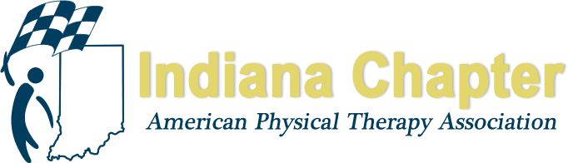

INAPTA ANNUAL REPORT

PAC Chair

Brad Shupe

HIGHLIGHTS FROM 2018
Following the PT Day at the Statehouse, we set a goal of raising $15,000 for this upcoming election season.
We Held our first PAC Golf Outing at the Legends Golf Course in Franklin on June 9th. We had over 40 participants at 10 sponsorships. It was a very fun-filled (briefly rainy) day and we were able to raise aroun$6500 for the PAC.
Southeast district hosted their annual wine tasting fundraiser on September 5th at River City Winery in New Albany, IN. It was an evening filled with wine, music, and networking. Great job Robin!

PROJECTIONS FOR REMAINDER OF 2018 AND 2019
Planning our first ever beer/wine/chocolate/bourbon tasting event at the Indiana and Kentucky joint fall conference on 9/21. We will be putting the best beers and wines from Kentucky and Indiana up against each other to raise money for a worthy professional cause. During the reception, we will also be holding a small auction.
I am looking forward to hosting a bigger and better golf outing next spring. Location, dates, and times TBD

