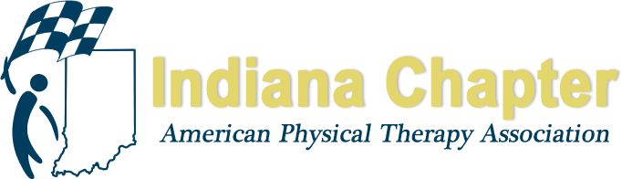

INAPTA ANNUAL REPORT

Director at Large- North

Gail Altekruse

HIGHLIGHTS FROM 2017
Northwest District- Alyssa Keys- Chairperson, Paul Young- Secretary/ Treasurer
Meetings held on the third Tuesday, monthly, except the summer months.
Highlight was the PAC fundraiser in March with a trivia contest between teams.
North Central District- Chris Frentz- Chairperson, Anne Clifford- Recoding Secretary
Meeting in May
Golf Outing Sponsorship
5/1/18 Business Meeting held, Diets and Nutrition Impacts on Healing – host Penrose PT
Facebook page
Elections – Treasurer position currently vacant
1/23/18 Meeting- Differential Diagnosis of Dizziness- host ATI
Northwest District - Leaders to be elected. Special thanks to Brooke Nack and Natalie Myers for their help with district meetings in April and May.

PROJECTIONS FOR REMAINDER OF 2017 AND 2018
Nominations and elections for NE district leadership positions
NC District
November Meeting to update on IUSB growing PT program
November Meeting to update / town hall for Practice Act
PT Pub Night 10/11/18 at SB Brew Works- PT Day of Service Fundraiser (Sarah Keenan)
Looking into PAC fundraiser, possible wine tasting event (Villa Macri wine room?)
Meetings for all districts regarding legislative initiatives beginning in October

