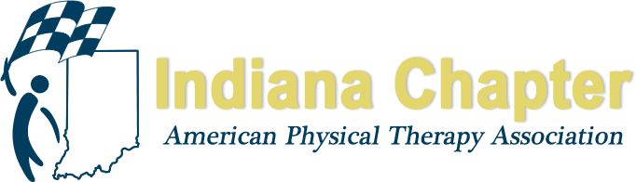

INAPTA ANNUAL REPORT

Legislative Committee

Pauline Flesch

HIGHLIGHTS FROM 2018
Initiated meetings at the end of 2017 to draft revised practice act for introduction in 2019
Successfully negotiated with chiropractors, reaching an agreement related to dry needling; we did not oppose language in their 2018 bill adding dry needling to chiropractors scope and they will not oppose our proposed language to do the same in 2019.
Supported the Public Relations committee with PT Day at the Statehouse in January 2018
Completed proposed language for revision of practice act which closely follows FSBPT model practice act language; with input from APTA, the INAPTA Board of Directors, and exceptional dedication by the legislative committee to review language in detail a nearly finalized draft is prepared.
A special thanks to Mark Scherer who formatted the language consistent with Indiana legislative services practice act format. And also special thanks to Steve Beebe for his consistent attendance and participation in the drafting process.

PROJECTIONS FOR REMAINDER OF 2018 AND 2019
Finishing touches and final tweaks are being made to the practice act language.
A communication strategy is being outlined for stakeholders, legislators and sponsors.
Discussions to vet new language will begin in fall with legislators.
January 2019 – introduce bill to update practice act
Key Points in new practice act language:
- Clarifies that “dry needling” is within the scope of physical therapy practice
- Creates 7-person independent Physical Therapy Board to regulate the practice of PT
- Adds a definition of physical therapy aide
- Provides title protection
- Expands direct access from 24 to 90 days.
- Adds a definition of “consultation by telemedicine”.
- Limits the number of times an individual can take the physical therapy licensure examination to six.

Special Thanks to Legislative Committee:
Peter Altenburger
Steve Beebe
Deanna Hayes
Stephanie Kelly
Paul Lonnemann
Emily Slaven

