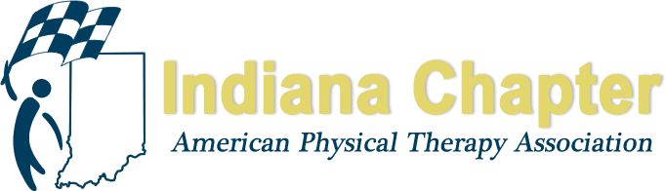

INAPTA ANNUAL REPORT

Chapter Ethics Committee

Paul E Young, PT, Chair

HIGHLIGHTS FROM 2017 - 2018
1] The Ethics and Jurisprudence Course available from the Chapter online for the mandatory requirements under Rule 8 was presented live at the Indiana Chapter Fall Meeting in September 2017 in Indianapolis by Renee Van Veld from the University of Indianapolis.
2] An ethical inquiry made to the Chapter President was reviewed by the Ethics Committee members and involved a scope of practice issue. The analysis of the matter is ongoing.

PROJECTIONS FOR REMAINDER OF 2017 AND 2018
1] The Ethics Committee would like to undertake a formal analysis of the online Ethics Course, now thru three, full two year, license cycles. Interested in stability of usage by licensees, passage rates of the exam and perhaps a survey of those having chosen two or more options in fulfilling their requirements, in terms of satisfaction and recommended improvements for the process and the course the Chapter offers.
2] Investigate opportunities to amplify efforts in ethics education of members at the Chapter and District level, supplementing those materials available at the national level.
3] Initiate a dialogue at this Fall 2018 Meeting in Louisville with Chapter colleagues in Kentucky regarding Ethics consultation, education and enforcement to gain an understanding of differences and similarities in experience.

