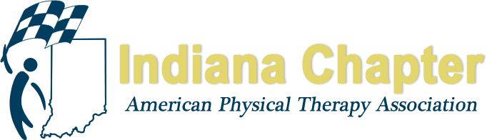

INAPTA ANNUAL REPORT

Director at Large-Central

Ryan Cotton, PT

HIGHLIGHTS FROM 2017
Central District

Current Officers (as of elections in April 2018)
- Chelsea Savage-Chair
- Hannah Enochs-Vice Chair
- Lauren Deike-Treasurer
- Danielle Storie-Sec
- Donna Peterson, Josh Weyer, Bryan Gezon-Nom Committee

2018 CD meetings
- Jan 19, 2018-CSM presentations
- June 17, 2018-SRT hosted

Upcoming meeting schedule
- Fall meeting (Oct) will be devoted to Practice Act updates
- Spring meeting: Student Panel

Course
- CD hosted Jeff Ryg for a Man PT course on May 12, 2018
- Poor attendance, lost money, thus updating Course/Speaker agreements as noted below

Requested meeting with Director, possibly other BOD rep to define roles and responsibilities
- Will likely happen at/around fall conference

Communications
- Projects for board include: reorganizing central district member database of PTs and clinics to advertise meetings; start using FB live or Zoom for streaming meetings
- Facebook page created, shared Google drive for board, Smartsheet being used for team tasks

Ortho SIG/Peds SIG

Director at Large-Central is now responsible for Ortho SIG and Peds SIG reporting to BOD

SIG Pub night social gathering Aug 30

Peds (Stasia Tapley)
- Wants list serve, working with webmaster
- Having meeting at Fall Conference
- Hoping to host course March 2019
Ortho (Lina Avendano)
- Updated bylaws, added student position
- Upcoming election, having difficulty filling the ballot
- Hosting Manual PT course Oct 27, 2018

PROJECTIONS FOR REMAINDER OF 2017 AND 2018
Updating District by-laws with Sean Bagbey for consistency between Districts
Developing consistent Speaker agreements and guidelines for SIG and District hosting of Cont Ed courses
Defining Director role through a written/updated job description
Will meet with CD leadership to define roles and responsibilities of their positions

