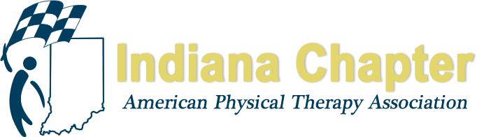

INAPTA ANNUAL REPORT

Bylaws Committee

Sean Bagbey, PTA

HIGHLIGHTS FROM 2018
The Bylaw committee has spent the year working on coming up with a model bylaws for the Districts.
This adjustment is designed to make all the district bylaws uniform and to allow similar time lines for
Positions as well as setting up a user friendly documentation to assist with each running each district
With ease and uniformity. We are in the process of getting feed back from all districts at this time.

PROJECTIONS FOR REMAINDER OF 2018 AND 2019
We will continue to work with each district to make sure that we preserve all areas of the bylaws that
They need as we assist with bringing all district bylaws with in the framework of what the chapters bylaws.

