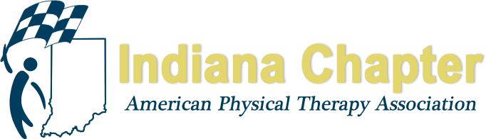

INAPTA ANNUAL REPORT

Awards & Scholarships Committee
Jessica Prothero, Chair

HIGHLIGHTS FROM 2018
Integrated Team Rehab scholarships for SPTs & SPTAs. One SPT scholarship for each PT program in the state and one SPTA scholarship for the entire state can be awarded each year. Had an overwhelming response from IU, UIndy, and Trine University programs. No applications from ISU or University of Evansville programs. A few applications received from SPTAs. Email blasts were sent by INAPTA and program directors were contacted by Chair regarding these scholarship opportunities. The selection process was tedious for the committee this first year; we are working on making the process more efficient via the use of a gmail account and Google Docs.

Awarding INAPTA SPT and SPTA scholarships this year.

Awarding one Specialty Certification Exam scholarship this year; two are available each year.

Both recipients of the Specialty Certification Exam scholarship from 2017 passed their exams in 2018 & received the remainder of their scholarship funds.

Will be awarding Certo, Emerging Leader, Bill Rosenbaum Friend of PT, and Schneider PTA Recognition awards in 2018. No nominations for Ekstam in 2018.

PROJECTIONS FOR REMAINDER OF 2018 AND 2019
Plan for potential nominations from IN Chapter for APTA awards.

Streamline student scholarship application process and committee review process.

Establish PTA Advanced Proficiency Exam scholarship.

Potentially establish Outstanding PT/PTA Team award.

