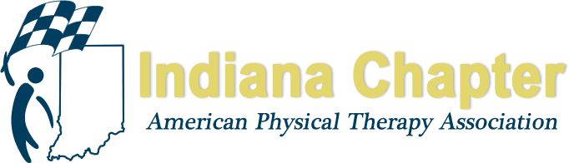
2017 INAPTA FALL CONFERENCE

OCTOBER 27-28, 2017

FRIDAY, OCTOBER 27, 2017

The Rathskeller Restaurant
401 E Michigan Street
Indianapolis, IN 46204

MEET THE CANDIDATES RECEPTION (5-5:30 pm)

BUSINESS MEETING (5:30-7pm)

AWARDS DINNER AND CEREMONY (7-8:30 pm)

MEMBERSHIP SPEED DATING EVENT (8:30-10:00 pm)

SATURDAY, OCTOBER 28, 2017

UNIVERSITY OF INDIANAPOLIS
HEALTH PAVILION
INDIANAPOLIS, IN

Track I - Integration of Movement System Impairment With Orthopedic Manual Therapy in the Cervical Spine
Speaker: Doug Mallers, PT, OCS, FAAOMPT

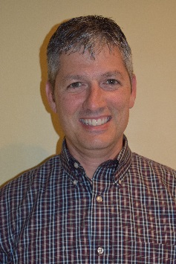

Course Description

This half day course will focus on application of integrating a Movement System Impairment approach and orthopedic manual therapy evaluation and intervention for cervical spine pain and dysfunction. We will review clinical anatomy and biomechanics in the upper quarter. We will evaluate the mobility of the cervical spine and discuss typical patterns of impaired movement as well as evaluate the cervical spine manually with passive segmental mobility testing. We will implement intervention for neuromuscular impairments as well as for restoration of ideal vertebral mobility thru joint mobilization. Emphasis will be on practical, clinical application for all levels of the physical therapist’s experience and expertise.

Course Objectives

After completing this course, the participant will be able to:

- Have an understanding of clinical anatomy and biomechanics of the cervical spine.
- Identify common movement system impairments in the upper quarter.
- Have a base line understanding in cervical passive physiological and accessory intervertebral motion testing.
- Prescribe appropriate exercise intervention to correct neuromuscular balance in the upper quarter.
- Perform appropriate and safe manual therapy intervention to assist in restoring joint and soft tissue mobility and integrity.

Speaker Information

Doug Mallers, PT, OCS, FAAOMPT is a Fort Wayne native and a 1992 graduate of Indiana University’s Physical Therapy School. He is a graduate of The Gulf Coast Post-Gradual Physical Therapy Program and received his Fellowship in Orthopedic Manual Physical Therapy from the American Academy of Orthopedic Manual Physical Therapists in 1998. He is in private practice in Fort Wayne with Mallers & Swoverland Orthopaedic Physical Therapy. He has been a faculty member of The Manual Therapy Institute, based out of San Marcos, Texas since 1999.

Track II - Walking the Walk: Translation of Scientific Findings Into Clinical Practice

Speakers: T. George Hornby, PT, PhD and Jennifer Moore, PT, DHS, NCS

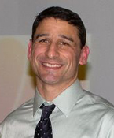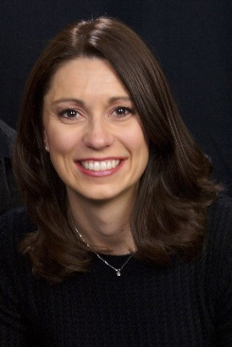

Course Description

More than 17 years could pass before the evidence that is published today is used in clinical practice. Knowledge translation (KT) includes the generation of new knowledge and its application into practice. Research suggests that use of processes, such as the Knowledge-to-Action Framework, and multi-component KT interventions may improve the success of KT efforts. In this educational session, attendees will learn about KT processes and theory and complete a workshop activity related to development of a KT action plan.

As an example of successful KT, this symposium will also provide an overview of the evidence related to intensive locomotor training in patients with neurologic injury and KT interventions used to successfully translate this research into the assessment and treatment of patients with subacute stroke during inpatient rehabilitation. Emerging research regarding specific conditions of stepping practice, such as the amount, intensity and variability of locomotor practice will be described. Data that describe the outcomes of specific KT interventions used to implement this evidence, feasibility of its implementation, and the impact of these KT initiatives on clinicians’ behavior and patient outcomes will be presented. Strategies used to implement this gait training program in two separate rehabilitation hospitals will be presented.

Course Objectives

After completing this course, the participant will be able to:

- Define knowledge translation.
- Explain the phases of the knowledge-to-action framework.
- Describe the rationale and evidence regarding the importance of amount, intensity, and variability of locomotor practice.
- Explain how these training parameters can be applied during clinical physical therapy sessions.
- Describe specific strategies to facilitate translation of evidence into clinical practice, including use of the Knowledge-to-Action Framework, audit and feedback, and leadership support.

Speaker Information

Dr. T. George Hornby PT, PhD is a professor of physical medicine and rehabilitation at Indiana University and the director of the Locomotor Recovery Laboratory at the Rehabilitation Hospital of Indiana. Dr. Hornby’s work is focused on optimizing rehabilitation interventions to improve lower extremity function in patients with stroke and spinal cord injury, with a primary focus on restoration of walking ability. By integrating both quantitative and clinical measures of motor function, Dr. Hornby’s work aims to understand the biomechanical and physiological impairments underlying limitations in locomotor activity in these populations, and the relative efficacy and mechanistic basis of specific interventions to enhance function. His recent activity focuses on direct translation of his research to clinical practice in the rehabilitation setting. Dr. Hornby has co-authored over 90 research publications in scientific journals. He is PI or Co-PI on active R01, DOD, and NIDRR center grants, with both national and international collaborations. He is also the Director of Research for the Academy of Neurologic Physical Therapy.

Jennifer Moore PT, DHS, NCS is the CEO of The Evidence Base, LLC and an advisor to the South Eastern Norway Center for Knowledge Translation in Rehabilitation. Her current work and research is focused on the selection and implementation of evidence-based assessments and interventions into clinical practice within hospital systems and across networks of hospitals in the United States and in Norway. Recently, Dr. Moore served as the Clinical Practice Leader of Neurologic Physical Therapy at the Rehabilitation Institute of Chicago and directed the development of the Rehabilitation Measures Database (www.rehabmeasures.org), which is a free, online repository of summaries of psychometric properties and clinical utility of over 300 assessments used in rehabilitation. Dr. Moore is currently co-leading an APTA sponsored Clinical Practice Guideline on a core set of outcome measures for neurologic physical therapy and was the guest editor for the Journal of Neurologic Physical Therapy’s special issue on knowledge translation research.

TRACK III - LAMP
Speakers: Emily Becker, PT and Kerry Wood, PT, DPT

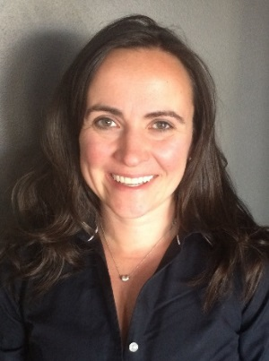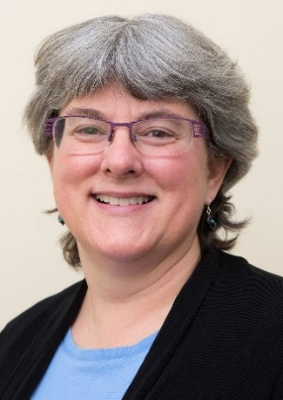

Course Description

The Leadership, Administration, Management, and Professionalism (LAMP) certificate program was developed by the Section on Health Policy and Administration to address member needs in leadership, administration, management, and professionalism skills. LAMP is focused on leadership development through self-assessments, identification of tools needed to lead successfully, empowerment, and mentoring through practical applications. LAMP is valuable for all PTs and PTAs regardless of their position, managers, practice owners, clinicians, educators, researchers, and students who want to develop their leadership effectiveness.
LAMP Leadership 101 will focus on the development of leadership behaviors for facilitating autonomous practice, accountability, and professional values. Attendees will learn how to influence others to create effective relationships and achieve shared goals. Content areas include creating a personal mission statement and self-assessment; foundations of leadership; 5 practices of exemplary leadership; identifying personal styles; creating a leadership style to align and influence others; energy and time management; mentoring and coaching; communication for improved results; empowering leadership for ethical practice; and implementing personal leadership plans. Attendees will complete a leadership self-assessment and other prework.
Course Objectives

After completing this course, the participant will be able to:
- Identify and discuss the personal characteristics of an effective leader.
- Recognize the importance of accountability, values and ethics and their impact on personal leadership.
- Describe and model leader behaviors and communication styles that influence, align and empower others.
- Formulate effective responses to conflict in a variety of situations.

Speaker Information

Emily Becker is the Coordinator of Clinical Development for Marianjoy Rehabilitation Hospital, now part of Northwestern Medicine. She has the shared responsibility for planning, implementation, and evaluation of educational projects and strategies for Marianjoy Rehabilitation Hospital. Emily holds a graduate degree in Physical Therapy from Washington University and has 15 years of experience in the physical therapist field in rehabilitation service roles including direct care provider, quality assurance manager, facility manager, academic clinical coordinator for a physical therapy assistant program, Federation of State Boards of Physical Therapy exam item writer, Federation of State Boards of Physical Therapy exam task force member, and consultant as an expert witness. She currently serves the physical therapy profession as a Reviewer of Continued Competence for Federation of State Boards of Physical Therapy, Faculty for LAMP Leadership, Member of the LAMP Administration and Management Curriculum Development Committee, Education Programming Co-Chair for the Health Policy and Administration Section of the APTA, and Director of Leadership on Executive Board of Directors for the Health Policy and Administration Section of the American Physical Therapy Association.

Kerry Wood has been a practicing clinician for over 25 years, since receiving her Bachelor of Science degree in Physical Therapy from the University of Vermont in 1985. She received her tDPT from Simmons College in 2009. Kerry has clinical experience in hospital based outpatients, acute care and acute inpatient rehabilitation. Having almost 20 years in practice management, she currently serves as Therapy Manager for the Inpatient Rehab Center at Fletcher Allen Health Care, Colchester, Vermont. She teaches Practice Management for Physical Therapists at the University of Vermont and Simmons College. Kerry has served as Professional Practice Chair, Delegate/Chief Delegate and is currently the Federal Affairs Liaison and PAC Ambassador for the VT Chapter of APTA. She served as Program Committee member/Chair for the Section of Health Policy and Administration and currently serves as the Section Secretary. Exploring and living leadership promotes a personal transformative journey which helps individuals discover their strengths and find joy in all they do!

TRACK IV – Ethics and Indiana Jurisprudence
Speakers: Pauline Flesch, PT, MPS and Renee Van Veld, PT, MS

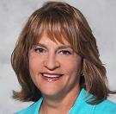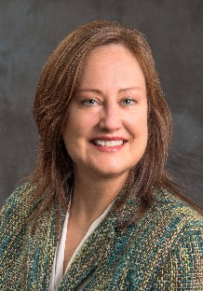

Course Description

This course on Indiana Physical Therapy Ethics and Jurisprudence is designed to provide a review of the ethical and legal standards that provide a basis for professional practice in Indiana. The current Indiana Practice Act is reviewed as well as a description of the concepts of non-maleficence, beneficence, autonomy, fidelity, veracity and justice in medical ethics and describes the individual and cultural differences that influence ethical practice. APTA core values, Guide for Professional Conduct, APTA Code of Ethics for the Physical Therapist and Standards of Ethical Conduct for the Physical Therapist Assistant serve as resources for this presentation. Clinical scenarios are used to assist clinicians in applying the resource documents to determine appropriate ethical behavior and provide an opportunity for self-reflection.

Course Objectives

After completing this course, the participant will be able to:

- Define the medical ethics concepts of non-maleficence, beneficence, autonomy, veracity, fidelity, and justice.
- Apply the current APTA Code of Ethics for the Physical Therapist, Standards of Ethical Conduct for the Physical Therapist Assistant, and APTA Guide for Professional Conduct in clinical scenarios to achieve ethical outcomes.
- Differentiate between legal and ethical principles in analyzing ethical dilemmas and/or case scenarios.
- Access current resource documents on the APTA website related to ethical practice of physical therapy.

Speaker Information

Pauline Flesch is the Executive Director of Rehabilitation and Fitness Services for Indiana University Health in Indianapolis, Indiana. IU Health is a statewide healthcare system consisting of 19 hospitals. Pauline graduated with a BS in physical therapy from The Ohio State University and received her Masters of Management in Public Service from DePaul University in Chicago, Illinois. She has been very active in the American Physical Therapy Association (APTA) at both the state and national level. Pauline served on the APTA Board of Directors 2001-2007, was past chairperson for the Federal Government Affairs Committee, past Indiana Chapter president and she continues to serve as Legislative Chairperson for the Indiana Chapter, as a delegate to the House of Delegates and as a member of the APTA Vision Task Force.

Renée VanVeld is an assistant professor and Director of Clinical Education in the Krannert School of Physical Therapy at the University of Indianapolis. She teaches classroom content related to evaluation and treatment of persons with amputations and persons with wounds, as well as content related to general clinical practice, ethics and professionalism. She prepares DPT students for and guides them through 39 weeks of clinical education during their three years in the program. She also facilitates relationships with clinical sites and clinical instructors to ensure quality clinical education for our students. She has been with UIndy since 2005. Areas of research interest include aspects of care for patients with lower extremity amputations, and teaching and learning of professionalism for graduate students.
Ms. Van Veld is a Credentialed Trainer for APTA's Credentialed Clinical Instructor Program, teaching this continuing education course at least twice a year in Indiana. Renee is a member of APTA, Education Section, APTA, Health and Policy Administration Section, APTA and the Indiana Chapter, APTA. She continues to work clinically at Eskenazi Health one day each week, focusing on treating patients with amputations as well as those with general orthopedic conditions.

TRACK V – STUDENT COURSE: What Is It Like When You’re Engaged as a New Professional?
Moderator: Sean Bagbey, PTA, BS, ATC

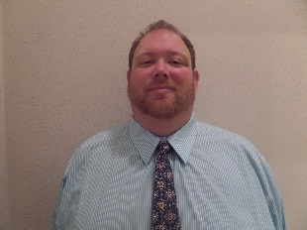

Course Description

This roundtable discussion will include INAPTA New Professional Members and will be moderated by Sean Bagbey, PTA. This course is geared toward new or soon to be graduates from PT and PTA programs who are interested in looking at what the start of your career really looks like.

We have all been new professionals at some point and realized that we needed help. As a new professional it is often times difficult to ask the questions that we all want to ask. This course is where you can ask these questions and also have the opportunity to learn from others.

We will examine the following and answer questions that may arise around the needs and wants of the audience. We will establish several interactive activities, as needed, to move the discussion forward:

- The ups and downs of starting a career.
- The reality of finding the correct working environment for you.
- How finding ways to support the passion for the profession works.
- How networking plays a role in the process from here forward.
- How to find and engage the mentors that are out there.
- How APTA and especially INAPTA have played a role in our development.

Course Objectives

After completing this course, the participant will be able to:

- Understand the importance of finding the direction of physical therapy that you want to pursue.
- Understand the realities of the current job market as well as the impact of payment reform and insurance reform.
- Identify opportunities that exist for mentorship within INAPTA and how to identify opportunities in your local community and district.
- Complete a personality and leadership self-assessment that will help identify personal strengths and weaknesses.

Speaker Information

Sean, a native of Evansville, IN, graduated from the University of Evansville in 2002 with his Bachelors in Athletic Training, Exercise Science, and Associates in Physical Therapy Assistance. Following graduation, he completed his Masters in Health Service Administration from the University of Southern Indiana. He is also a Certified Industrial
Rehabilitation Specialist. Sean is certified in the Functional Movement Systems, the Selective Functional Movement
Assessment Level I and II, Y-balance Testing, as well as, Case Management, Home Modification Design and Industrial Rehabilitation. He holds advanced proficiency in Musculoskeletal, Geriatrics, and Orthopedics from the American Physical Therapy Association (APTA) and has been active with APTA on a state and national level. Sean is married to another PTA, Carla, and has two children, Noah and Ainsley. He is an active member of his church. His interests include: playing with his children, archery, and golf.

