Driving Directions to Campus
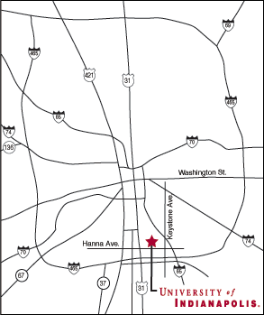

University of Indianapolis
Street Address
1400 East Hanna Avenue
Indianapolis, Indiana 46227

From the Northwest
Take I-65 south through Indianapolis to Exit 107 (Keystone Avenue). Turn right. Go to the third stoplight (Hanna Avenue); turn right. Once you pass the second stoplight (State Street), you have reached the UIndy campus. See the campus map for available visitor parking.

From the North
Take U.S. 31 south to I-465. Take I-465 east all the way around Indianapolis to Exit 53A (I-65 North). Now see “Exit 53A” below.

From the Northeast
Take I-69 south to I-465. Take I-465 south around the city to Exit 53A (I-65 North). Now see “Exit 53A” below.

From the East
Take I-70 or U.S. 40 west to I-465. Take I-465 south around Indianapolis to Exit 53A (I-65 North). Now see “Exit 53A” below.

From the Southeast
Take I-74 northwest to I-465. Take I-465 south around Indianapolis to Exit 53A (I-65 North). Now see “Exit 53A” below.

From the South
Take I-65 north to Exit 107 (Keystone Avenue); turn left. Go to the third stoplight (Hanna Avenue). Turn right. Once you pass the second stoplight (State Street), you have reached the UIndy campus. See campus map for available visitor parking.

From the Southwest
Take Ind. 67 or Ind. 37 northeast to I-465. Take I-465 east to Exit 2A (East Street). Now refer to “Exit 2A” below.

From the West
Take I-70 or I-74 east to I-465. Take I-465 south around Indianapolis to Exit 2A (East Street). Now refer to “Exit 2A” below.

Exit 2A
Go to second stoplight (Hanna Ave.); turn right. Go to the third stoplight (Otterbein Ave.). The campus is on the left. See campus map for visitor parking.

Exit 53A
Take I-65 north one exit to Exit 107 (Keystone Ave.); turn left. Go to the third stoplight (Hanna Ave.); turn right. Once you pass the second stoplight (State St.), you’re on campus. See campus map for visitor parking.

