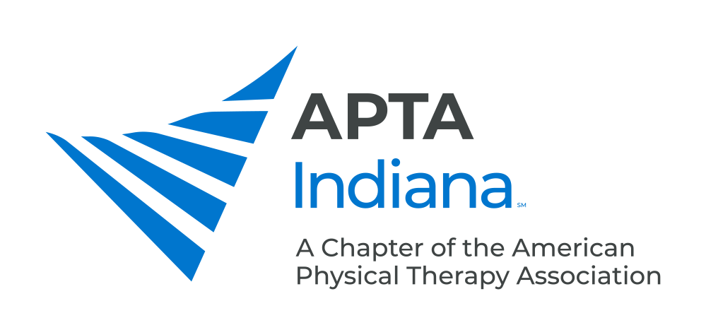

PRACTICE & PAYMENT SPECIALIST - PRACTICE & PAYMENT COMMITTEE

As a benefit of APTA Indiana membership, the Practice and Payment Specialist, working in conjunction with the Practice & Payment Committee, serves as a resource for practice and payment issues. This includes:

- Disseminating News/Updates
- Educating Membership on Practice & Payment Issues
- Addressing Questions and Concerns From APTA Indiana Members

Please reach out to Andrea Lausch, PT, DPT, Practice & Payment Specialist, at andrealausch@inapta.org with questions or to inform the Practice and Payment Committee of payer concerns.

APTA Indiana would like to proactively build positive relationships with the payer community in Indiana. The goal is to:

- Create an opportunity to provide payers with useful and pertinent information about our field in a collaborative atmosphere.
- Be a resource to payers.
- Improve payment for physical therapy, serving as a resource to payers, when considering payment policy decisions.
- Host a Payer Forum.

How Can APTA Indiana Members Help?

- Keep the APTA Indiana Practice and Payment Committee informed of payer issues so we can help!
- Help us build a database of payers, third-party administrators, and other payer organizations that would benefit from an improved knowledge base about physical therapy including:
  - Claims
  - Utilization Management
  - Case Management
  - Provider Relations or Professional Services
  - Department of Medical Directors, and Fraud Investigation Units
- Email Andrea Lausch, PT, DPT, Practice & Payment Specialist, at andrealausch@inapta.org, with the above information. Please include as much of the following information about payer representative contacts you have:
  - Name
  - Title and Company
  - Address
  - Phone
  - Fax
  - E-mail Address

